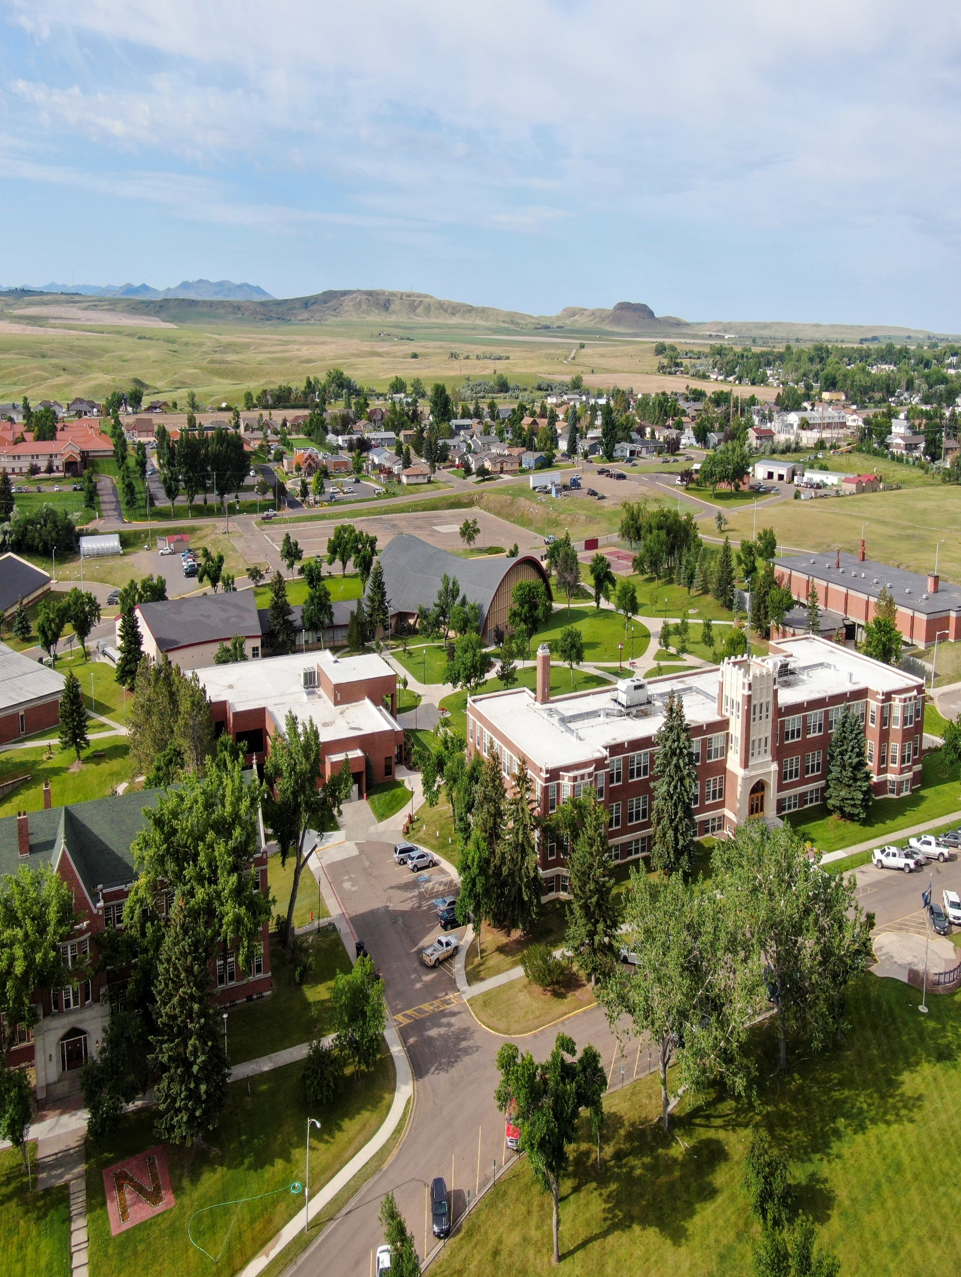

2026 ANNUAL SECURITY & FIRE SAFETY REPORT
MONTANA STATE UNIVERSITY - NORTHERN

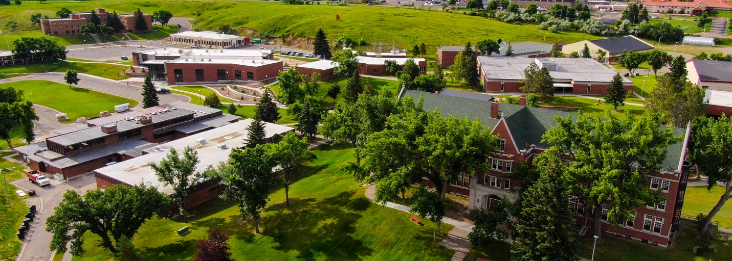

Nondiscrimination and Title IX Coordinator Notice Policy Statements
Montana State University-Northern (MSUN) commits to a learning and working environment that emphasizes the dignity and worth of every member of its community that is free from unlawful discrimination and harassment based upon race, color, religion, national origin, creed, service in the uniformed services (as defined in state and federal law), veteran status, sex, gender, age, political ideas, marital or family status, pregnancy, physical or mental disability, genetic information, gender identity, gender expression, or sexual orientation (taken together, generally, “protected-class harm”). An inclusive environment is necessary for a healthy and productive University community.
Consistent with MSUN’s commitment, and with all applicable law, the University prohibits unlawful discrimination or harassment, including sexual misconduct prohibited by Title IX of the Education Amendments of 1972, and will take appropriate action to prevent, resolve, and remediate the effects of protected-class harm.
The Discrimination, Harassment, and Retaliation Policy defines and prohibits protected-class misconduct, and the Discrimination Grievance Procedures set forth the University’s processes for addressing and resolving such reports. The Policy and Procedures apply to all University programs and activities, including, but not limited to, admissions, athletics, instruction, grading, University housing, and University employment. In addition, the law prohibits retaliation against an individual for opposing any practices prohibited by this Policy, for bringing or responding to a complaint of discrimination or harassment, for assisting someone with such a complaint, for attempting to stop such discrimination or harassment, or for participating in resolution of a complaint of discrimination or harassment.
Inquiries about the application of Title IX at the University and reports about all forms of protected-class discrimination and harassment should be made to:

Taryn Wallon  Dean of Students & Title IX Coordinator  taryn.wallon@msun.edu or titleixcoordinator@msun.edu  (406) 265-3539  Student Union Building 204  Morgaine Lomayesva  Coordinator for Accessibility Services for Students  morgaine.lomayesva@msun.edu  (406) 265-3533  Cowan Hall 213C | Montana State University-Northern  300 West 11th St  Havre, MT 59501  Montana State University-Northern  300 West 11th St  Havre, MT 59501
For further information on notice of non-discrimination, visit https://ocrcas.ed.gov/contact-ocr for the address and phone number of the office that serves your area, or call 1-800-421-3481.

Please note that reports can be made at any time, including during non-business hours, by using the email address or listed telephone number (and leaving a private message).

Table of Contents

Introduction 5

Campus Safety and Security Policies and Procedures 6
Campus Security Authorities 6
Havre Police Department 7
Havre Police Department Crime Log 7
Crime or Emergency Reporting 7
Additional Reporting Information and Guidance 8
Voluntary Confidential Reporting | General Crime 9

Campus Safety and Security Programs 10
Crime Prevention Education and Awareness | Havre Police Programs 10
Crime Prevention Education and Awareness | Campus Programs 10

Additional Campus Safety and Security Policies and Procedures 12
Missing Student Policy 12
University Weapons and Storage Policies 13
Automated External Defibrillators (AEDs) 13
Crime Statistics 14

Student Conduct Procedures 14
Student Conduct | Hearings 14
Student Conduct | Sanctions 14
(HEOA) Notification to Victims of Crimes of Violence 15
Parental Notification Policy 15

Security and Access in Campus Facilities 16
Facilities | Academic, Administrative, and Athletic 16
Facilities | Residential Facilities 16
Physical Plant and Maintenance 16

Campus Safety and Emergency Notifications 17
Timely Warnings 17
Emergency Notification System 18
Public Safety Advisory 19

Emergency Response and Evacuation Procedures 19
General Evacuation Procedures 20
Shelter-In-Place Procedures 20

Policies and Programs Addressing Domestic Violence, Dating Violence, Sexual Assault and Stalking 21
Introduction 21
Definitions of Domestic Violence, Dating Violence, Sexual Assault and Stalking 21
Discrimination, Harassment, and Retaliation Policy 22
Definition of Consent 25
Amnesty Policy 25
Retaliation Prohibited 25
What to Do If You Are a Victim of Domestic Violence, Dating Violence, Sexual Assault or Stalking 26
Reporting Domestic Violence, Dating Violence, Sexual Assault and Stalking 28
Filing a Report with the University, Law Enforcement or Anonymously 29
Confidential and Non-Confidential Resources 31
Campus Resources | Confidential 31
Campus Resources | Non-Confidential 32
Off-Campus Resources 33
University Response to Reports of Domestic Violence, Dating Violence, Sexual Assault and Stalking 33

Northern’s Non-Discrimination Grievance Procedures 35
Required Information on Procedures for Domestic Violence, Dating Violence, Sexual Assault and Stalking 35
Education and Outreach 36
Reducing Risk On-Campus and In Our Community 37

Sexual or Violent Offender List (Montana State Sex Offender Registry) 39

University Policies on Alcohol and Other Drugs 40
Policies 40
Alcohol 40
Drug-Free Workplace 41
Resources 41

Preparation of the Annual Disclosure of Clery Crime Statistics 43
Clery Definitions 43
Clery Geography 45
Campus Map 46

MSU-Northern Crime Statistics | 2022-2024 47
Clery Data 47
Unfounded Crimes 49
Hate Crimes by Category and Bias 49

Definition of Crime Categories Under Federal Law 49
Definition of Crime Categories Under Montana Law 52
Domestic Violence, Dating Violence, Sexual Assault and Stalking 52
Consent 55

State of Montana Laws on Alcohol and Other Illegal Drugs 56
Underage Consumption of Alcohol 56
Medical Amnesty 57
Carrying False Identification 58
Public Drunkenness 58
Driving Under the Influence of Substances 58
Selling or Furnishing Alcohol to Minors 60
Open Containers 60
Possession of Dangerous Drugs 61
Possession of Dangerous Paraphernalia (PODP) 61

2026 Annual Fire Safety Report for Reporting Year 2024 62
Introduction 62
Fire Reporting and University Response to Arson 62
University Fire Marshal 63
University Fire Safety Policies 63
Prohibited Acts 64
Fire Evacuation Procedures 64
Fire Safety Education and Training 65
Fire Drills and Fire Safety Systems 66
Fire or Life Safety Systems Status | 2024 66

Fire Safety Report Log | 2022-2024 67
Plans for Future Improvements in Fire Safety 68



Introduction

At Montana State University - Northern, the security and well-being of our students, faculty, staff and visitors is always a primary concern. Having a sense of belonging, feeling welcomed and safe is essential for members of our community to thrive, commit, and focus on their growth and goals.

MSU-Northern’s Annual Security and Fire Safety Report is prepared annually in compliance with the essential provisions of the federal Crime Awareness and Campus Security Act of 1990 and the Jeanne Clery Disclosure of Campus Security Policy and Campus Crime Statistics Act of 1998. Additionally, this report contains information demonstrating compliance with the 2022 reauthorization of the Violence Against Women Act (VAWA).

The Annual Security and Fire Safety Report is an important tool for our students, faculty, and staff to keep current on key university policies and statistics. We seek to provide valuable information for our campus community and strive to be transparent, open to feedback, and opportunities to enhance our relationships across campus and within the Havre community.

Each year, all enrolled students as well as University faculty and staff receive an e-mail notification describing how to access this report electronically. Prospective students and employees may also view this report online or printed copies are available upon request through the Dean of Students Office.

We encourage members of the university community to read through this report and use it as a guide for safe practices on and off campus. If you have questions or suggestions concerning this publication, please feel free to contact me at (406) 265-3539 or via email at deanofstudents@msun.edu.

Sincerely,

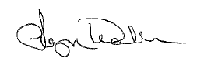

Taryn Wallon
Dean of Students & Title IX Coordinator

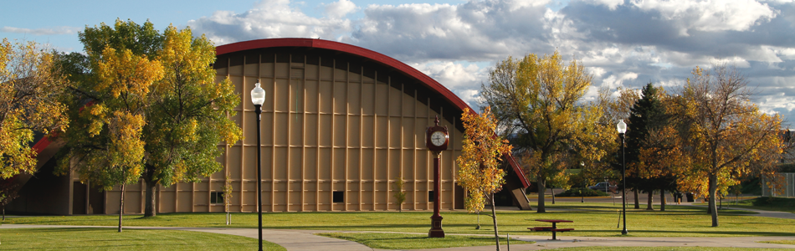
Campus Safety and Security Policies and Procedures

Campus Security Authorities

Campus Security Authorities (CSAs) include campus security-related personnel and officials who have significant responsibility for student and campus activities. These staff may include, but are not limited to, the Chancellor and Vice Chancellors at the University, Title IX Coordinator, Safety Officer, the Dean of Students and those designated to work with student conduct, Student Health Services staff, Resident Directors (RDs) in University housing, Athletics staff and coaches, and officials charged with hosting and managing events. CSAs who have been informed of an alleged crime must follow MSU-Northern procedures for ensuring inclusion in the annual crime statistics report. In addition, CSAs must report to other university officials, as appropriate, such as the Title IX Coordinator, or Dean of Students, to initiate any applicable investigative or other procedure.

Students, employees, and visitors are encouraged to promptly report crimes to the Havre Police Department. However, the Clery Act requires that the University also designate certain individuals as CSAs. Students and employees can report criminal offenses to designated CSAs for the purpose of making timely warning reports and annual statistical disclosure.

While there are a number of CSAs at Northern, the University officially designates the following two offices as locations where campus community members should report crimes:

Office of Human Resources Dean of Students Office
Cowan Hall 206 Student Union Building 204
hr@msun.edu titleixcoordinator@msun.edu
(406) 265-3568 (406) 265-3539

Whenever possible, University staff will do all they can to maintain confidentiality. However, confidentiality of crime reports made to CSAs cannot be promised. The Clery Act requires statistical reporting, but CSAs are also reporters under the requirements of Title IX and University policy and as such may not be able to maintain confidentiality. There may be instances where the University must act regardless of the wishes of the complainant or reporting party. Nevertheless, in such cases the University will take care to protect identities to the extent allowed by the circumstances and law.

Pastoral and Professional Counselors
Campus “Pastoral Counselors” and “Professional Counselors,” when acting as such, are not considered to be a campus security authority for Clery Act purposes and are not required to report crimes for inclusion in the annual disclosure of crime statistics.

According to the Clery Act, professional mental health counselors who are appropriately credentialed and hired by MSU-Northern to serve exclusively in a counseling role are not considered CSAs. As a matter of policy, the University encourages our professional mental health counselors to notify those whom they are counseling of the voluntary, confidential reporting options available to them.

Pastoral Counselor – MSU-Northern does not have any Pastoral Counselors that work at the institution at this time.

Professional Counselor – An employee of an institution whose official responsibilities include providing psychological counseling to members of the institution’s community, and who is functioning within the scope of their license or certification. MSU-Northern employs one full-time counselor, available to students.

Please note that reports of sexual violence and other violations that may be sex- or gender-based may also be reported to the Title IX Coordinator and may not be held in confidence.

Havre Police Department

MSU-Northern does not employ a Campus Safety or University Police Department. However, the University has established a written Memorandum of Understanding (MOU) with the Havre Police Department (HPD) for the response to and the investigation of crimes that occur on or in close proximity to campus property, as well as at local University events. The memorandum also establishes HPD as a support entity that may be asked to assist University staff in safely addressing violations of campus policy that may or may not be classified as a crime. This arrangement serves to enhance University efforts through an increased safety and security presence after hours, on weekends, or otherwise as needed.

HPD officers are encouraged to make regular rounds of campus grounds, check in with staff as they encounter them, and to be available for basic security support. Additionally, HPD has been actively engaged in presentations, trainings and communication related to personal and institutional safety and has worked to build relationships within the Northern community.

Havre Police Department Crime Log

The Havre Police Department (HPD) provides a public daily crime log, accessible through the Havre Daily News. It can be found at https://www.havredailynews.com/section/local/record.

Crime or Emergency Reporting

MSU-Northern Campus | 300 West 11th Street, Havre, Montana
Crime is an unfortunate reality on any university campus, and preventing crime is everyone’s responsibility. Unreported crime is a criminal’s greatest ally. To help provide a safe and secure environment, all members of the MSU-Northern community on the Havre Campus, including campus visitors, are encouraged to report any criminal activity or emergency they observe.
- For emergencies call 8-911 from on-campus phones.
- For emergencies call 911 from cell phones.
- For non-emergencies that require police assistance, call (406) 265-4361 (Havre Police Department).
- For facility or access concerns, call MSU-Northern Facility Services (406) 265-3755.
- For other non-emergency health or safety concerns, call the Dean of Students (406-265-3539) or the Office of Human Resources (406-265-3789).

Suspicion of crime does not require proof. If you suspect a crime has been committed or is being committed, call 911 (or 8-911 from on-campus phones). Make a difference and call. Concerned citizens can prevent crime.

Great Falls College MSU Campus | 2100 16th Avenue South, Great Falls, Montana
To help provide a safe and secure environment, all members of the MSU-Northern community participating in MSU-Northern classes or programming at the Great Falls College MSU campus in Great Falls are encouraged to report any criminal activity or emergency they observe.

Contact the Great Falls Police by dialing 911 in an emergency. Contact (406) 727-7688 in a non-emergency situation. Please report all crimes to the Great Falls Police Department.

Additional Reporting Information and Guidance

If You Are a Victim or Witness of a Crime
Report the incident immediately to the Havre Police Department, the Office of Human Resources and Title IX, or the Dean of Students Office. If you can, gather pertinent information, such as sex, race, hair color, length and texture, body size, clothing description, scars and other noticeable characteristics, modes of travel, type, color and license information for any vehicles.

If You Encounter Suspicious Persons
If you see anyone acting suspiciously, call 911 (or 8-911 from on-campus phones). Do not approach the individual yourself. Report the type of suspicious behavior and the location. Relay pertinent information concerning the involved person, including age, sex, dress, vehicle and direction of travel.

If You Receive a Bomb Threat
If you receive a bomb threat, it is important to obtain as much information as possible from the caller. Things to ask are: (1) location of bomb, (2) time of explosion, and (3) type of bomb.
Make mental notes about the caller’s voice, and background noises which you may hear. Immediately call 911 (or 8-911 from on-campus phones). Do not panic. Law enforcement will search the area, notify properly trained personnel, and notify emergency services. The Havre Police Department, in conjunction with the building supervisor and University administration, will determine if evacuation is necessary.

What to Report
When calling to report an incident, please remember to provide the following information:

- Your name (optional)
- Location of incident
- Type of incident
- Description of suspect, vehicles or other pertinent information
- Return telephone number (optional)

Members of the MSU-Northern community are encouraged to accurately and promptly report crime and emergencies to the appropriate campus and law enforcement officials, including when the victim of a crime elects to, or is unable to, make such a report.

Voluntary Confidential Reporting | General Crime

If you are the victim of a crime and do not want to pursue action within the University or criminal justice systems, you may still want to consider making a confidential report, which can be done through Dean of Students or Human Resources Offices. It is important to note that any report of a Title IX violation should be directed to the Title IX Coordinator per the guidelines outlined in the Policies and Programs Addressing Domestic Violence, Dating Violence, Sexual Assault and Stalking section of this report.

The purpose of a confidential report is to comply with your wish to keep the matter confidential, while taking steps to ensure the future safety of yourself and others. With such information, the University can keep an accurate record of the number of incidents involving students, employees and visitors; determine where there is a pattern of crime with regard to a particular location, method, or assailant; and alert the campus community to potential danger. Reports filed in this manner are counted and disclosed in the annual crime statistics for the institution.

If you wish to make a confidential report, MSU-Northern offers the Silent Witness Program to anyone who has witnessed, or knows about, a crime committed on campus. The Silent Witness reporting form can be found online at:

https://www.msun.edu/stuaffairs/campussafety/silentwitness.aspx.

Please keep in mind this program is not intended for crimes in progress or for emergencies. Call 911 (or 8-911 from on-campus phones) in these instances.

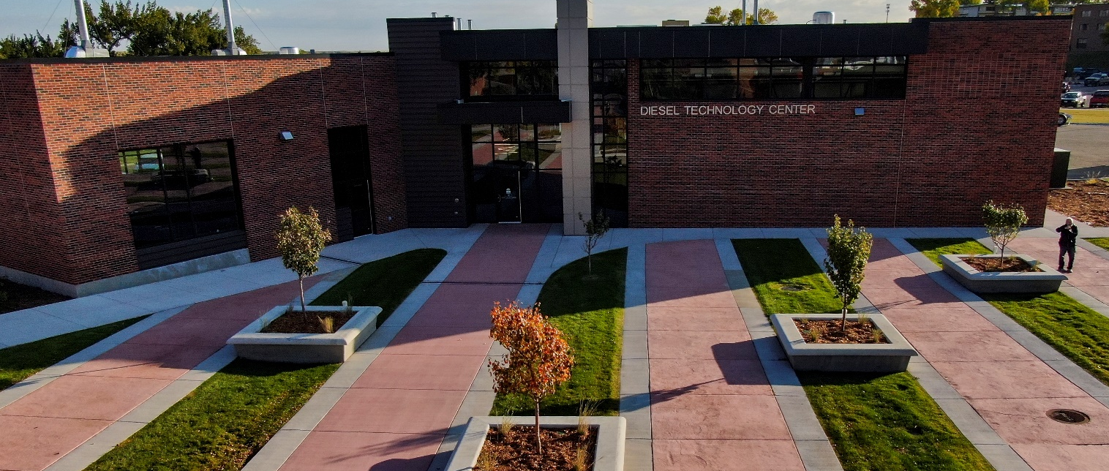

Campus Safety and Security Programs

Preventing crime is a shared campus responsibility. Every campus community member should play an active role in making the University environment safe and secure from criminal activity. An important aspect of all crime prevention and security awareness programs at MSU-Northern is the encouragement of students and employees to be responsible for their own security and the security of others.

Educational programs concerning personal safety, crime prevention, including prevention of domestic violence, dating violence, sexual assault, hazing, and stalking, are offered a number of times each year by various organizations, including Havre Police Department, Student Health Services, Residence Life, and others. Presentations and trainings include, but are not limited to, the following topics:

- alcohol and drug awareness (includes Thriving Together MSUN for all students);
- sexual misconduct (domestic violence, dating violence, sexual assault, and stalking – includes Haven for all students);
- suicide prevention and awareness (includes QPR training made available to all members of the campus community each semester);
- hazing and bystander intervention;
- active threat protocols;
- fire safety for all students in residence halls;
- fire safety trainings for key student and professional staff (CPR, fire extinguisher, chemical safety trainings, cyber security, etc.).

Residence hall students receive information regarding safety & security and university rules and regulations through building wide meetings at the beginning of each semester as well as floor meetings throughout the year.

All faculty and staff routinely attend security awareness, campus threat response, and crime prevention trainings during annual employee meetings, orientations, and throughout the year. Employees are required to attend bi-annual trainings that cover Title IX, sexual misconduct, domestic violence, dating violence, and stalking prevention.

Crime Prevention Education and Awareness | Havre Police Department Programs

The Havre Police Department plays an active role in assisting with campus safety and security programs on-campus, providing trainings related to personal and institutional safety. Additionally, their presence on-campus provides them the opportunity to cultivate relationships with our campus community that promote proactive communication and trust.

While programming and presentations vary some from year-to-year, active threat training is provided for all new students during orientation. Havre Police Department provides active threat training for employees as requested by MSU-Northern.

Crime Prevention Education and Awareness | Campus Programs

CARE Team
Montana State University-Northern cares about the health and safety of the campus community. The CARE Team was developed to centralize the reporting, assessment, and management of concerns regarding student behavior. This team includes qualified and dedicated professionals from various disciplines that are committed to promoting a productive and safe environment for all students.

The CARE Team serves 5 primary functions:
- Gather information to assess situations involving students who display concerning or disruptive behaviors.
- Recommend appropriate intervention strategies.
- Connect students with needed campus and community resources.
- Provide consultation and support to all employees in assisting students who display concerning or disruptive behaviors.
- Monitor and review ongoing behavior of students who have displayed disruptive or concerning behavior.

The CARE Team acts in a proactive manner to identify, assess, manage, and respond to students in academic or personal distress and to educate the campus community related to trends and best practices in student support. It shall maintain confidentiality and handle all matters discreetly. The CARE Team is not an emergency response team. If behaviors require emergent attention, call 911.

More information about the CARE Team’s membership, mission, and procedures can be found at:

https://www.msun.edu/admin/policies/300/310.aspx.

Behavioral Intervention Team (BIT)
To support and enhance the CARE Team’s efforts, MSU-Northern implemented a Behavioral Intervention Team (BIT) in the summer of 2021 to assist with reviewing and responding to high-level student behavioral concerns, advising institutional response to students who have disclosed criminal history as part of the campus safety and security questionnaire, and to inform the Chancellor and the campus community, when directed, as to the risk of potentially concerning or disruptive behavior.

The BIT is chaired by the Dean of Students and convenes at least twice per month throughout the academic year. The BIT primarily reviews referrals made by the CARE Team or the Admissions Office. The BIT also assesses and recommends response to any significant threat to students and the campus community, including risks of self-harm, harm to others, and significant disruption to the campus environment.

Residential Education
Residential Education provides information about safety and security concerns primarily through floor and building meetings with residents throughout the semester. Additionally, concerns related to safety, security, facilities, or other issues are communicated routinely to students through email.

Residential Education staff programming efforts typically seek to address ongoing concerns related to college student needs (alcohol and drug use, mental or emotional health and wellness, community living, and academic support). Additionally, Residential Education provides important information and trainings related to fire safety and emergency response.

Residential Education staff serve in an on-call capacity for students living on-campus 24/7. Resident Assistants (RAs) in residence halls complete nightly rounds throughout the semester and throughout most breaks. The Dean of Students lives on-campus as well, ensuring that there is access to a professional staff member quickly, should the need arise.

Though RAs are charged with responding to and reporting violations of the Student Code of Conduct, Northern believes that the relationships formed with students in University housing are essential to safety and security efforts. As a result, we place a heavy emphasis on getting to know the students in our community and building trust throughout the academic year.

Additional Campus Safety and Security Policies and Procedures

Missing Student Policy

MSU-Northern adheres to expectations established in the Higher Education Opportunity Act of 2008 and Montana state statute (Montana Code Annotated 44-2-408) governing emergency contact designation and law enforcement response to missing persons reports, respectively.

Reports of missing students should be made to the Havre Police Department (406-265-4361) or the Dean of Students Office (406-265-37539 or deanofstudents@msun.edu). Reports of missing students who reside in campus housing may also be made to the Residential Education Office (406-265-3539 or residentialed@msun.edu). When a missing person is reported to the University directly, the University will immediately:

- determine credibility of the report, to the best of their ability;
- if credible, the University will institute action to find the student and notify the Havre Police Department and specified University officials;
- if the student has designated a confidential contact for missing persons reports, the University will notify that contact.

The Havre Police Department, when notified of a missing person, will also adhere to Montana state statute (Montana Code Annotated 44-2-408), which indicates:
- All law enforcement authorities in the state shall accept, without delay, a report of a missing person unless there are extenuating circumstances, including:
  - the law enforcement authority knows the location of the person reported missing;
  - the law enforcement authority confirms the safe status of the person reported missing;
  - the law enforcement authority confirms that another law enforcement authority has or will accept a missing person report for the person; or
  - other circumstances documented by the law enforcement authority.

- All missing person reports must be entered into the database of the National Crime Information Center (NCIC) of the United States Department of Justice within:
  - 2 hours of receipt for persons under 21 years of age; or
  - 8 hours of receipt for persons 21 years of age or older.

- If a missing person is not located within 30 days of being reported missing, the law enforcement authority that took the report shall ensure a complete and accurate record of information is compiled for the missing person, including a photograph if one is available.

Per the Higher Education Opportunity Act of 2008, students may designate a confidential contact to be notified in the event the student is determined to be missing. The confidential contact is to be notified by MSU-Northern no later than 24 hours after the determination is made. The University will attempt to notify the confidential contact within two hours if the missing student is under 21 years of age and within eight hours if the missing student is over 21 years of age. This determination is made collaboratively between University officials and the Havre Police Department (or other local law enforcement agencies involved). Confidential contact information will be accessible ONLY to authorized University officials and will not be disclosed, except to law enforcement officials in furtherance of a missing person investigation.

In the event a student is under 18 years of age and not emancipated, MSU-Northern must notify a custodial parent or guardian within 24 hours of the determination that the student is missing, in addition to notifying any additional contact person designated by the student. Regardless of whether the student has identified a confidential contact, is above the age of 18, or is an emancipated minor, MSU-Northern will inform the local police department (or the local law enforcement with jurisdiction) that the student is missing.
Students are encouraged to keep confidential contact information and their whereabouts up to date, as this will help considerably during an investigation. To add or change your confidential contact, please contact the MSU-Northern Dean of Students Office (406-265-3539 or deanofstudents@msun.edu).

University Weapons and Storage Policies

Fireworks, firearms, bows, knives (4-inch blade or longer) other weapons or explosives are prohibited on the MSU-Northern campus. This prohibition includes all campus buildings, residences, in vehicles and all land. The use of these items on campus is prohibited.

Exemptions to this policy may be granted by the Chancellor or his/her designee for specific functions (gun shows, gun raffle, etc.). Requests for exemptions to this policy must be made in writing to the Chancellor or his/her designee, at least ten days prior to the function.

Students residing in University housing must store all weapons within the locked cabinets provided through the Residential Education Office. Storage of any weapon in a parked vehicle on campus is strictly prohibited.

If unchecked firearms (or any of the items listed above) are found on campus, disciplinary action may be taken. Owners, or those in possession, who are students may be subject to suspension. Non-students in violation of this policy will be asked to remove the item from the campus. Failure to comply with this, will result in criminal trespassing charges. Official law enforcement personnel while on duty are exempt.

The University’s Firearms, Miscellaneous Weapons, Fireworks and Explosives policy can be found online at http://www.msun.edu/admin/policies/1000/1004-4.aspx.

Automated External Defibrillators (AEDs)

MSU-Northern currently has 10 AEDs located throughout campus. Please contact the Office of Human Resources & Title IX (406-265-3568) for inquiries or to report that an AED has been used and emergency services have been called.

Crime Statistics

Crime statistics can be found later in this report and can also be accessed on the MSU-Northern website located at: https://www.msun.edu/stuaffairs/campussafety/.

Student Conduct Procedures

The student conduct process at MSU-Northern exists to challenge those whose behavior is not in accordance with our policies and to foster a better understanding of the expectations that exists for members of our academic community. The vast majority of conduct cases at MSU-Northern are resolved through administrative meetings. These are conversations between the student and a Conduct Officer.

During an administrative meeting, the Conduct Officer will provide the student an opportunity to share their account of the incident, view incident reports and other written documentation, ask follow-up questions, and discuss potential outcomes (sanctions) if the student is found responsible for violating the Code of Student Conduct. The primary focus of these meetings is to determine if a violation took place, assist the student in understanding the impact of their behavior, and provide a space for the student to begin reflecting on how to learn from the incident.

If it is determined that a violation of the Code of Student Conduct occurred, and that the student is responsible, most administrative meetings conclude with an administrative agreement in which the student agrees to take responsibility for their involvement in the incident and to complete a sanction or set of sanctions that will help them learn from the incident.

The Code of Student Conduct can be found online at http://www.msun.edu/admin/policies/600/601-3.aspx.

Student Conduct | Hearings

The conduct process also includes a more formal route for resolving conduct cases called a conduct hearing. A conduct hearing is utilized if an administrative agreement cannot be reached or if the student chooses to participate in a hearing instead of first meeting with a Conduct Officer. The procedures and guidelines for conduct hearings are detailed in the Code of Student Conduct (Section 601.3).

Student Conduct | Sanctions

Sanctions are intended to improve the students’ moral and ethical decision-making and to help them learn more about what is expected as members of our community. The Conduct Officer will determine an appropriate sanction, taking into consideration the student’s past disciplinary record (including Residence Hall disciplinary record), the nature of the offense, the severity of any damage, injury, or harm resulting from the violation, and other factors relevant to the case.

Additionally, more than one sanction may be assigned upon the completion of a hearing or proposed by a conduct officer. In cases where students fail to demonstrate an understanding of established conduct standards or pose a threat to the continuing safety of the academic community, the conduct officer may determine that the student should no longer share in the privilege of being a student member of MSU-Northern’s academic community.

(HEOA) Notification to Victims of Crimes of Violence

MSU-Northern will disclose upon written request the results of any disciplinary proceeding, conducted by such institution, to the alleged victim of a crime of violence or a non-forcible sex offense against a student who is the alleged perpetrator of such crime or offense. If the alleged victim is deceased as a result of such crime or offense, the next of kin of such victim shall be treated as the alleged victim for purposes of this disclosure.

Disclosure of the results of a proceeding to the charging student and the charged student in compliance with these provisions does not constitute a violation of section 444 of the General Education Provisions Act (20 U.S.C. 1232g), commonly known as the Family Educational Rights and Privacy Act of 1974 (FERPA).

Parental Notification Policy

Montana is one of two states in the country where State privacy law is more restrictive than Federal privacy law. Montana Code Annotated 20-25-515 prevents any State agency from releasing student records. When the Family Education Rights to Privacy Act (FERPA) was amended in 1998 to include parental notification provisions, the Montana University System determined that the above state law would prohibit such notification without the consent of the student.

MCA 20-25-515 can be found here: https://leg.mt.gov/bills/mca/title_0200/chapter_0250/part_0050/section_0150/0200-0250-0050-0150.html

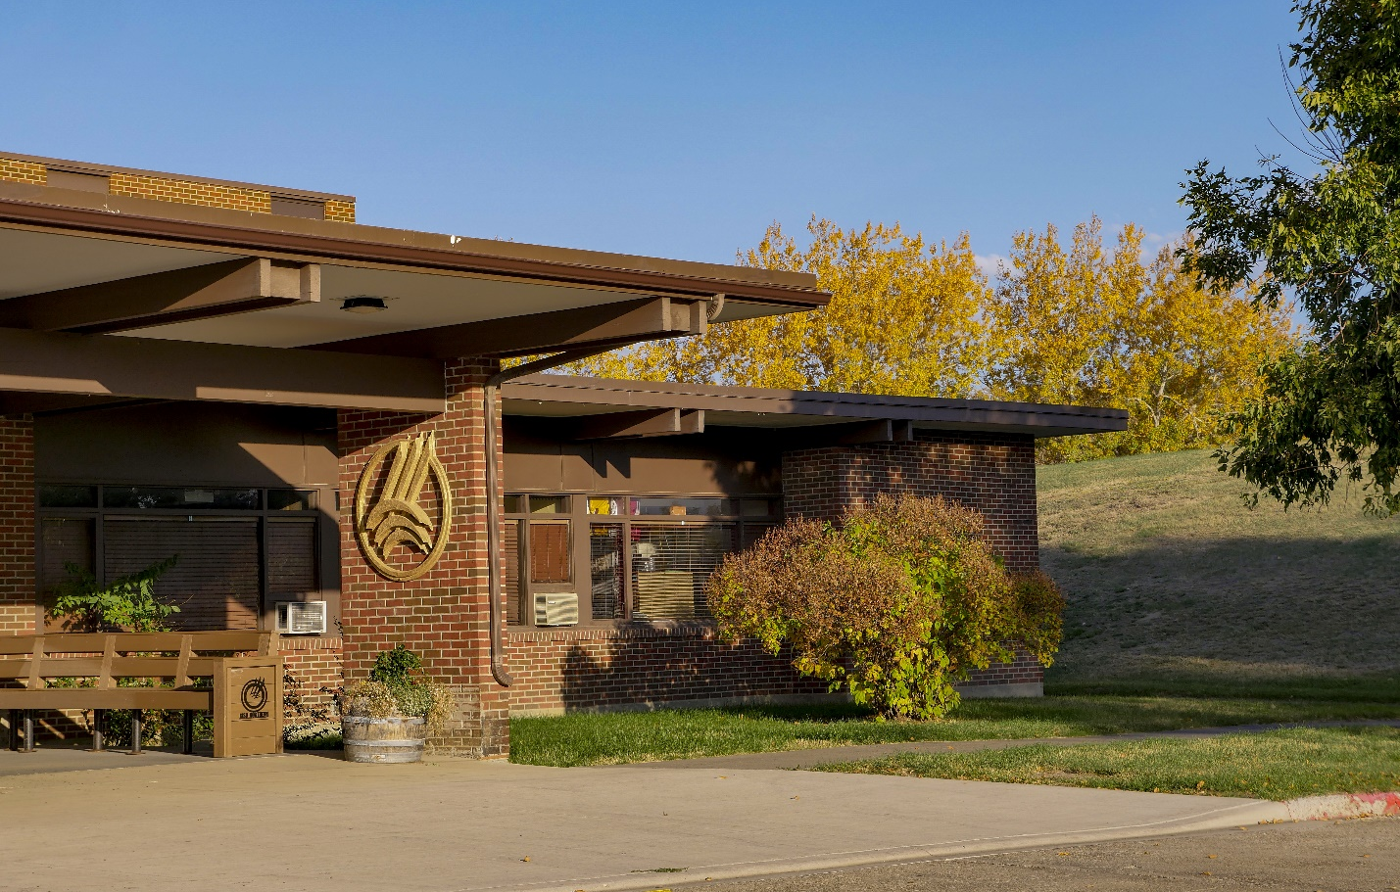

Security and Access in Campus Facilities

Facilities | Academic, Administrative, and Athletic

It is the policy of MSU-Northern that other than during normal working hours, all buildings shall be locked in order to maintain the security of both the buildings and their contents (Campus Policy Section 903.3, found online at http://www.msun.edu/admin/policies/900/903-3.aspx).

Primary security in buildings is maintained through a master key system managed by Facilities Services. Building coordinators have been appointed for each building, and they have primary authority to approve issuance of keys to building occupants and approve transfer of keys between individuals. This key system provides access for authorized students, staff and faculty to academic buildings during closed hours. Key access is provided with appropriate written supervisory approvals. Campus buildings (non-residence) are normally open from 6:00 AM – 11:00 PM (closing times may vary) Monday through Friday or for scheduled weekend classes and special events but are locked at all other times. Anyone entering a locked room or area is responsible for locking the protected space when they leave.

In addition, the university has adopted the following additional security practices:
- Rules that prohibit propping exterior building doors when they are locked and secured.
- Policy (Campus Policy 903.1) that grants the right to prohibit, limit or otherwise restrict access to or use of its buildings, facilities or other property as may be necessary to provide for the orderly conduct of the University’s educational and service programs and the safety and security of campus property, students, employees, guests and other visitors (found online at https://www.msun.edu/admin/policies/900/903-1.aspx).
- Substantial outdoor lighting installations and regular lighting assessments to help deter criminal behavior and enhance security.
- A policy requiring background checks for new employees.

Facilities | Residential Facilities

Students are responsible for their personal safety and the safety of their property. Students are encouraged to always keep their room doors locked. Students are encouraged to report any suspicious behavior to a Resident Assistant (RA), Resident Director (RD, the Residential Education Office, or to the Havre Police Department.

Within residence hall communities, RAs conduct building rounds nightly during the academic year. Residence halls are locked 24/7 and residents are provided access to their assigned building using an electronic key fob. Camera systems monitor primary entrances and exits to each building.

Physical Plant and Maintenance

Facilities Services provides a call-out program to provide maintenance services during after-hour, weekend, and holiday periods. Special assignment of keys, where required (such as contractors, etc.), may be authorized by the campus Facilities Services Director.

Generally, all maintenance requests, questions, or concerns can be directed to:

Facilities Services
Physical Plant
physicalplant@msun.edu
(406) 265-3755

Additionally, students living in University housing can contact Resident Assistants (RAs), Resident Directors (RDs) or Dean of Students for maintenance requests. The student must inform the individual to whom they are reporting the problem if they would like to be present when the work order is completed. The facilities department issues a 24-hour notice of entry prior to completing work in our student family housing area. In times of emergency, members of the facilities department have permission to enter living areas to make the necessary repairs. Off-campus maintenance personnel are not allowed access to residential areas without permission from the Facilities Services Director.

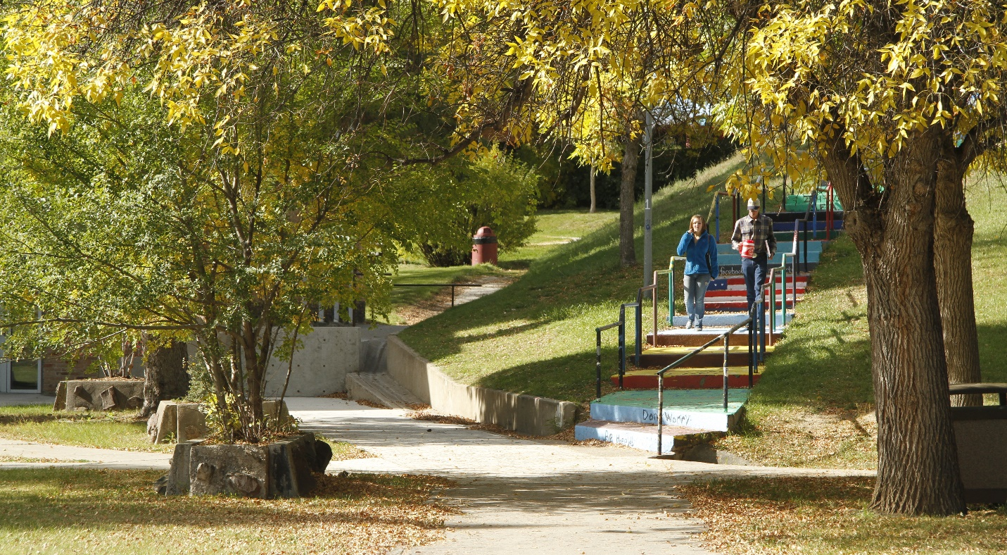

Campus Safety and Emergency Notifications

Timely Warnings

In the event a crime is reported or brought to the attention of a CSA, that occurred within the MSU-Northern Clery Geography (On Campus, Public Property and Non-Campus property), and that, in the judgment of the Chancellor and in consultation with other campus administrators (including, but not limited to: Dean of Students, Legal Counsel, Director of Human Resources & Title IX Coordinator) when time permits, constitutes a serious or continuing threat, a campus wide “timely warning” notice will be issued.

Timely warning notices will be distributed to the entire campus community as soon as pertinent information is available, in a manner that withholds the names of victims as confidential, and with the goal of aiding in the prevention of similar occurrences. Timely warning notices are typically issued for the following Uniform Crime Reporting Program (UCR)/National Incident Based Reporting System (NIBRS) crime classifications: murder/non-negligent manslaughter, sex offenses, robbery, aggravated assault, burglary, major incidents of arson, motor vehicle theft, and hate crimes. Cases of aggravated assault and sex offenses are considered on a case-by-case basis, depending on the facts of the case and the information known by University officials, local law enforcement, and legal counsel. Timely warning notices may be distributed for other Clery crimes, as determined by the Chancellor or designee.

The Chancellor or designee reviews all timely warning notifications. Timely warning notices will typically include information such as a brief statement of the incident, physical description of any suspect(s), appropriate safety tips, and other relevant, available information.

As with emergency notifications (described in detail below), timely warning notices will be distributed via messaging using University e-mail, postings on the MSU-Northern website and social media pages, and messaging on all campus computers. The University will use some or all of the systems described above when issuing a timely warning to the campus community.

Per Clery requirements, an institution that follows its emergency notification procedures is not required to issue a timely warning based on the same circumstances; however, MSU-Northern will provide adequate follow-up information to the community as needed.

The institution is not required to issue a timely warning with respect to crimes reported to a pastoral or professional counselor.

Emergency Notification System

MSU-Northern’s Emergency Notification Policy can be found online at:

https://www.msun.edu/admin/policies/1000/1004-7.aspx.

The policy provides that the University will issue an emergency notification to the campus community in the event of a serious or continuing threat to campus. This same emergency notification system is used for timely warnings as well.

The MSU-Northern Emergency Notification System delivers critical information to MSUN students, faculty, and staff in the event of an emergency. The system delivers emergency messages through text messaging, University e-mail, postings on the MSU-Northern website and social media platforms, and messaging on all campus computers. Face-to-face communication may also be used to communicate emergency information. The University will use some or all of the systems described above to communicate the threat to the MSU-Northern community or to an appropriate segment of the community, should the threat be limited to a particular building or segment of the population. The local news media may be utilized to disseminate emergency information to members of the larger community, including neighbors, parents and other interested parties. The larger community can also access emergency information via the MSU-Northern website and via University social media.

Upon confirmation that an emergency or dangerous situation poses and immediate threat to the health or safety of some or all members of the MSU-Northern community, the Chancellor or designee will quickly decide whether to issue an emergency notification or timely warning, taking into consideration the severity and type of emergency or threat. The Chancellor or designee will also determine the appropriate audiences to receive notice. The Chancellor or designee are the only staff authorized to issue an emergency notification.

The University will, without delay, and taking into account the safety of the community, determine the content of the notification and initiate the notification system, unless issuing a notification will, in the professional judgment of responsible authorities, compromise efforts to assist a victim or to contain, respond to, or otherwise mitigate the emergency.

MSU-Northern will test its emergency response and evacuation procedures on an annual basis through scheduled drills, exercises, and other activities designed to assess and evaluate emergency plans and capabilities. Tests may be announced or unannounced. Tests will be documented and assessed.

Public Safety Advisory

Public Safety Advisories are used to notify students, faculty, and staff of situations that do not pose an immediate threat to life safety, buy may require awareness to reduce the risk of being victimized by telephone or email scams, fraud, etc. These notifications and follow up information are sent via email.

If there is an immediate threat to the health or safety of students or employees occurring on campus, MSU-Northern will follow its emergency notification procedures.

Anyone with information about a situation that may require the issuance of a timely warning, emergency notification, or public safety advisory should report the circumstances to the following offices:

Office of Human Resources
Cowan Hall 206
hr@msun.edu
(406) 265-3789

Dean of Students Office
Student Union Building 204
deanofstudents@msun.edu or titleixcoordinator@msun.edu
(406) 265-3539

Emergency Response and Evacuation Procedures

MSU-Northern is committed to protecting the lives, safety, and welfare of its campus and community members.

Maps showing a means of egress can be found on the exit doors leading from each residential space and in hallways of other buildings. You should become familiar with these exit routes for any building you frequent.

In case of a fire or other emergency that requires all occupants to immediately leave a building or area, evacuation will be signaled by the internal building alarm or by the direction of emergency personnel. MSU-Northern will test its emergency response and evacuation procedures on at least an annual basis through scheduled drills, exercises, and appropriate follow through activities designed to assess and evaluate the emergency plans and capabilities.

General Evacuation Procedures

At the sound of a fire alarm or if you are instructed to evacuate, leave your work, study, or living area immediately and proceed to the nearest exit, and leave the building. If you are the first to recognize a fire situation, activate the alarm, evacuate to a safe location using the nearest exit and dial 911.

In the event of an emergency:
- Remain calm.
- Do NOT use elevators; use the stairs.
- Assist the physically impaired. If they are unable to exit without using an elevator, secure a safe location near a stairwell, and immediately inform responding emergency services personnel (Havre Police Department, Havre Fire Department, or University staff) of the individual’s location.
- Proceed to a clear area at least 150 feet from the building. Keep all walkways clear for emergency vehicles.
- Make sure all personnel are out of the building.
- Do not re-enter the building.

Specific campus policies related to Inclement Weather (Section 1004.2); Security and Safety – Fire (1004.3); Firearms, Miscellaneous Weapons, Fireworks and Explosives (1004.4); and Active Shooter Incident (1004.6) can be found on the University’s website at https://www.msun.edu/admin/policies/1000.aspx.

MSU-Northern’s Emergency Notification Policy can be found online at https://www.msun.edu/admin/policies/1000/1004-7.aspx.

Shelter-In-Place Procedures

A Shelter in Place notification may be issued during a severe weather event, a hazardous materials incident, or an active threat to the campus. The MSU-Northern Emergency Notification System will be used to issue the notice of a shelter in place. Instructions of immediate actions will be provided in the MSU-Northern Emergency Notification System. Three types of messages may be issued “Shelter in Place – Secure”, “Shelter in Place - Weather”, and “Shelter in Place – HAZMAT”.

Specific campus policies related to Inclement Weather (Section 1004.2); Security and Safety – Fire (1004.3); Firearms, Miscellaneous Weapons, Fireworks and Explosives (1004.4); and Active Shooter Incident (1004.6) can be found on the University’s website at https://www.msun.edu/admin/policies/1000.aspx.

MSU-Northern’s Emergency Notification Policy can be found online at https://www.msun.edu/admin/policies/1000/1004-7.aspx.

Policies and Programs Addressing Domestic Violence, Dating Violence, Sexual Assault, and Stalking

Introduction

Montana State University-Northern prohibits the crimes of domestic violence, dating violence, sexual assault, and stalking (as defined by the Clery Act and Title IX regulations) and reaffirms its commitment to maintaining a campus environment that emphasizes the dignity and worth of all members of the University community.

Toward that end, MSU-Northern maintains programs to prevent and address domestic violence, dating violence, sexual assault, and stalking as well as the procedures for institutional disciplinary action in cases of alleged dating violence, domestic violence, sexual assault, or stalking. As indicated in the University’s Discrimination, Harassment and Retaliation Policy (found online at https://www.msun.edu/hr/titleix/index.aspx), the definition of Sexual Harassment includes sexual assault, dating violence, domestic violence, and stalking.

MSU-Northern recognizes that these issues can impact anyone regardless of their sex, gender, gender identity, gender expression, or sexual orientation. Campus services are available to all victims. Throughout this section, the term victim will be used to refer to anyone who experiences a Clery-covered crime. MSU-Northern recognizes that individuals may use a variety of terms to describe themselves and their experience.

Definitions of Domestic Violence, Dating Violence, Sexual Assault, and Stalking

MSU-Northern uses the definitions of domestic violence, dating violence, sexual assault and stalking as stated in the Clery Act to determine crimes documented in this report. However, it is important to note that MSU-Northern’s definitions, as outlined in Campus Policy 1001.7 Discrimination, Harassment, Sexual Misconduct, Dating Violence, Domestic Violence, Stalking, and Retaliation (found online at https://www.msun.edu/hr/titleix/index.aspx), and Montana criminal law definitions vary somewhat from Clery Act definitions.

The following are the definitions provided in MSU-Northern Campus Policy:

Domestic Violence (Section 127.00) is an act of violence committed by:
- a current or former spouse of the victim,
- by a person with whom the victim shares a child in common,
- by a person who is cohabitating with or has cohabitated with the victim as a spouse,
- by a person similarly situated to a spouse of the victim under the domestic and family violence laws of Montana [Title 40, Ch. 15, MCA]
- by any other person against an adult or youth victim who is protected under the domestic or family violence laws of Montana. Persons protected include mothers, fathers, brothers, sisters, and other past and present family members of a household.

To the extent applicable as provided in Sections 100.30 and 100.50 above, allegations of domestic violence, regardless of whether they are based on discrimination, shall be addressed and considered in accordance with this Policy and MSU-Northern’s Discrimination Grievance Procedures.

Dating Violence (Section 126.00) is abuse or violence between, partners or persons in a social relationship of an intimate or romantic nature involving one or more of the following elements:
- Battering that causes bodily injury;
- Emotional abuse creating apprehension of bodily injury or property damage;
- Repeated telephonic, electronic, or other forms of communication -- anonymously or directly -- made with the intent to intimidate, terrify, harass, or threaten.

The existence of such a relationship shall be determined based on consideration of the following factors:
- The length of the relationship;
- The type of relationship; and
- The frequency of interaction.

To the extent applicable as provided in Sections 100.30 (Off-Campus Conduct) and 100.50 (Applicability), allegations of dating violence, regardless of whether they are based on discrimination, shall be addressed and considered in accordance with this Policy and MSU-Northern’s Discrimination Grievance Procedures.

Sexual Assault (Section 125.00) means an actual or attempted sexual contact with another person without that person's consent. Sexual assault includes, but is not limited to:
- Involvement in any sexual contact when the victim is unable to consent.
- Intentional and unwelcome contact with the breasts, buttock, groin or genitals or touching another with any of these body parts or coercing or forcing or attempting to coerce or force another to touch the perpetrator or themselves with or on any of these body parts.
- Any other intentional bodily contact in a sexual manner, including contact by a penis, tongue or finger, and oral copulation (mouth to genital contact or genital to mouth contact).
- Sexual intercourse without consent, including acts commonly referred to as "rape."

Stalking (Section 128.00) is engaging in a course of conduct directed at a specific person would cause a reasonable person to:
- Fear for the person’s safety or the safety of others; or
- Suffer substantial emotional distress.

For the purpose of this definition- a. A course of conduct means two or more acts, including, but not limited to, acts which the stalker directly, indirectly, or through third parties, by any action, method, device, or means – follows, monitors, observes, surveils, threatens, or communicates to or about, a person, or interferes with a person’s property.

To the extent applicable as provided in Sections 100.30 and 100.50 above, allegations of stalking, regardless of whether they are based on discrimination, shall be addressed and considered in accordance with this Policy and MSU-Northern’s Discrimination Grievance Procedures.

Discrimination, Harassment, and Retaliation Policy

The Discrimination, Harassment, and Retaliation Policy defines and prohibits protected-class misconduct, and the Discrimination Grievance Procedures set forth the University’s processes for addressing and resolving such reports. The Policy and Procedures apply to all University programs and activities, including, but not limited to, admissions, athletics, instruction, grading, University housing, and University employment. In addition, the law prohibits retaliation against an individual for opposing any practices prohibited by this Policy, for bringing or responding to a complaint of discrimination or harassment, for assisting someone with such a complaint, for attempting to stop such discrimination or harassment, or for participating in resolution of a complaint of discrimination or harassment.

Discrimination
Discrimination is conduct based upon an individual’s race, color, religion, national origin, creed, service in the uniformed services (as defined in state and federal law), veteran status, sex, gender, age, political ideas, marital or family status, pregnancy, physical or mental disability, genetic information, gender identity, gender expression, or sexual orientation (“protected classes”) that:
1. Adversely affects a term or condition of an individual’s employment, education, living environment, or participation in a University Program or Activity; or

2. Is used as the basis for or a factor in decisions affecting that individual’s employment, education, living environment, or participation in a University Program or Activity; or

3. Constitutes Harassment, as defined below, by unreasonably interfering with an individual’s employment, educational performance, on-campus living environment, or participation in a University Program or Activity.

Discrimination includes failing to provide reasonable accommodation to persons with disabilities. Under the Policy, a person with a disability means a person with a physical or mental impairment that substantially limits a major life activity; has a record of such impairment; or is regarded as having such an impairment. Determinations of whether individuals have a physical or mental impairment that substantially limits a major life activity (and therefore have a disability) are made on a case by case basis. In accordance with the Americans with Disabilities Act (ADA), as amended, Section 504 of the Rehabilitation Act of 1973, and applicable federal and state laws, the University is committed to providing access and reasonable accommodation in its services, programs, activities, education, and employment for individuals with disabilities.

An exception to the definition of Discrimination is a bona fide occupational qualification.

Harassment

The University prohibits two forms of Harassment as described below: (1) Discriminatory Harassment; and (2) Sexual Harassment.

Discriminatory Harassment

Discriminatory Harassment is unwanted conduct that is: (a) based upon an individual’s race, color, religion, national origin, creed, service in the uniformed services (as defined in state and federal law), veteran status, sex, gender, age, political ideas, marital or family status, pregnancy, physical or mental disability, genetic information, gender identity, gender expression, or sexual orientation; and (b) that has the purpose or effect of unreasonably interfering with a reasonable person’s participation in a University Program or Activity.

Discriminatory Harassment emphasizes the consequence of conduct on an individual’s participation in a University Program or Activity3. The following factors will be considered in assessing whether conduct objectively constitutes an unreasonable interference in a University Program or Activity:

  - The identity of the parties, the nature of the parties’ relationship, and the influence of that relationship on the complainant(s)'s employment or education;

  - The nature, scope, frequency, and duration of the protected class conduct;

  - The degree to which the protected class conduct affected one or more students’ education or individuals' employment; and

  - The nature of higher education.

Sexual Harassment

Acts of Sexual Harassment may be committed by any person upon any other person, regardless of the sex, gender, sexual orientation, and/or gender identity of those involved.

Sexual Harassment is conduct that: (1) occurs within a University Program or Activity located in the United States; (2) affects an individual participating or attempting to participate in a University Program or Activity at the time the Formal Complaint is filed; (3) is based on sex, gender identity, gender expression, or sexual orientation; and (4) satisfies the elements of Quid Pro Quo Conduct, Hostile Environment, Sexual Assault, Domestic Violence, Dating Violence, Stalking, or Sexual Exploitation, as defined below.

a. Quid Pro Quo Conduct occurs when:
i. an employee of the University,
ii. conditions the provision of an aid, benefit, or service of the University,
iii. on an individual’s participation in unwelcome sexual conduct.

b. A Hostile Environment is created by:
i. unwelcome4 conduct,
ii. determined by a reasonable person,
iii. to be so severe, and
iv. pervasive, and,
v. objectively offensive,
vi. that it effectively denies a person equal access to a University Program or Activity.

Consistent with MSUN’s commitment, and with all applicable law, the University prohibits unlawful discrimination or harassment, including sexual misconduct prohibited by Title IX of the Education Amendments of 1972, and will take appropriate action to prevent, resolve, and remediate the effects of protected-class harm.
Inquiries about the application of Title IX at the University and reports about all forms of protected-class discrimination and harassment should be made to the Title IX Coordinator:

Montana State University-Northern
PO Box 7751
Havre MT 59501
Dean of Students / Title IX Coordinator:  Taryn Wallon  Student Union Building 204  Tel: (406) 265.3539  E-mail: titleixcoordinator@msun.edu or taryn.wallon@msun.edu | Director of Human Resources / Title IX Coordinator:  Rebecca Farr  Cowan Hall 208  Tel: (406) 265.3569  E-mail: rebecca.farr@msun.edu

Definition of Consent

MSU-Northern defines Consent for the purposes of deciding if University policy prohibiting sexual assault, has been violated. The following is the definition of Consent, as provided in MSU-Northern Campus Policy:

Consent (Section 125.00) is an understandable exchange of affirmative words or actions, which indicate a willingness to participate in mutually agreed upon sexual activity. Consent must be informed, freely and actively given. If coercion, intimidation, threats, or physical force are used there is no consent.
There is no consent if a person is mentally or physically incapacitated so that such person cannot understand the fact of or make a reasonable judgment as to the nature or harmfulness of the conduct, or extent of the sexual situation. This includes incapacitation due to mental disability, alcohol or drug consumption, or being asleep or unconscious. A person who knows or reasonably should have known that another person is incapacitated may not engage in sexual activity with that person.
There is no consent when there is force, expressed or implied, or use of duress or deception upon the victim. In the absence of mutually understandable words or actions, it is the responsibility of the initiator, or the person who wants to engage in the specific sexual activity to make sure that he/she has the consent from his/her partner(s). Silence does not necessarily constitute consent. Past consent to sexual activities does not imply ongoing future consent. Whether an individual has taken advantage of a position of influence over an alleged victim may be a factor in determining consent. Effective consent may not be given by minors less than 16 years old.

Amnesty Policy

The University strongly encourages students to report instances of sex-based discrimination, sexual harassment, and sexual misconduct involving students. Therefore, students who provide information about sex-based discrimination, sexual harassment, sexual misconduct, dating violence, domestic violence, or stalking involving students will not be disciplined by the University for any violation of the University's drug or alcohol possession or consumption policies in which they might have engaged in connection with the reported incident.

Retaliation Prohibited

Retaliation is prohibited by MSU-Northern policy and federal law. Retaliation against any person for reporting concerns, or filing, testifying, assisting, or participating in any manner in investigations or proceedings involving allegations of violation of the Discrimination Policy, is prohibited. Retaliation is subject to the same Discrimination Grievance Procedures (found online at https://www.msun.edu/hr/titleix/index.aspx) and the same potential sanctions.
What to Do If You are a Victim of Domestic Violence, Dating Violence, Sexual Assault, or Stalking

There is no right or wrong way to respond if you are a victim of domestic violence, dating violence, sexual assault, or stalking. It is important to remember that it is not your fault. The following are options you can consider, but you don’t have to do anything you don’t want to do.
If you are a friend helping someone who is a victim, support their decisions and try to not tell them what to do. Find ways to help them make decisions for themselves.

Seek Medical Attention
After an incident of sexual assault, dating or domestic violence, you should consider seeking medical attention as soon as possible at Northern Montana Health Care (NMHC), offering physical evidence recovery kit collection, access to forensic nurse examiners and/or sexual assault nurse practitioners. NMHC Sexual Assault Nurse Examiners (SANE) are specially trained and are sensitive to the needs of assault survivors. In the State of Montana, evidence may be collected and held for a year even if you choose not to make a report to law enforcement. If you are uncomfortable going to the hospital, you can go to Student Health Services for a wellness check, but they cannot do forensic exams.

Preserve Evidence
Although it is important for you to make decisions about the kind of service you want, timing is an important factor. It may be important to take action to preserve any evidence for use in a criminal case, even if you aren’t sure what you want right now.

Medical forensic evidence may be collected if a sexual assault occurred within 120 hours of the evidence collection. The passage of time may make it more difficult, but not impossible, for a SANE to obtain forensic evidence. You may request an exam and forensic evidence collection at no cost and without having to file a police report. The costs of the evidence collection will be covered as part of Montana’s Forensic Rape Examination Payment Program. The NMHC Emergency Room is the only location in Havre which conducts forensic examinations.

If you are considering a medical forensic exam, it is important that you try not to clean your body, change your clothes, or change any bed linens or other items that may have been near where the assault occurred. This helps preserve evidence that police can use in a criminal case, i.e., proving that the alleged offense occurred, or if you’re requesting a protective order.

Even if you do not opt for forensic evidence collection, health care providers can still treat injuries and take steps to address concerns of sexually transmitted infections and/or pregnancy.
You are also encouraged to preserve evidence by saving text messages, instant messages, social networking pages, other communications, and keeping pictures, logs or other copies of documents, if you have any, that would be useful to a campus and/or criminal investigation. Other evidence of a crime should also be preserved in case criminal charges are pursued. Evidence might include pictures of injuries, forensic examination, written and electronic communications, text messages, emails, photos, or and other evidence that may show a course of conduct.

If you want to talk about these options confidentially, you can talk to anyone on the list of confidential resources provided above.

Victim Support | Rights and Institutional Commitments
Regardless of whether a victim elects to pursue a criminal complaint or university process, the University will assist victims of domestic violence, dating violence, sexual assault, and stalking and will provide each victim with a written explanation of their rights and options. Such written information will include:

- the procedures victims should follow if a crime of dating violence, domestic violence, sexual assault or stalking has occurred;
- information about how the institution will protect the confidentiality of victims and other necessary parties;
- a statement that the institution will provide written notification to students and employees about victim services within the institution and in the community;
- a statement regarding the institution’s provisions about options for, available assistance in, and how to request accommodations and protective measures; and
- an explanation of the procedures for institutional disciplinary action.

It does not matter where the victim experienced the behavior, MSU-Northern is here to work with victims regardless of where the crime occurred.

Victim Support | Institutional Responsibility for Orders of Protection, “No Contact” Orders, Restraining Orders, or Similar Lawful Orders Issued by a Criminal, Civil, or Tribal Court or by the Institution

MSU-Northern complies with Montana law in recognizing orders of protection or criminal no contact orders by coordinating with the parties to the Order as needed to ensure access for the individual who has protection under a Court Order. Any person who obtains an order of protection from Montana or any reciprocal state should provide a copy to the Office of Human Resources & Title IX. A complainant may then meet with the Office of Human Resources & Title IX to develop a Safety Action Plan, which is a plan to assist the victim with reducing the risk of harm while on campus or coming and going from campus. This plan may include, but is not limited to: escorts, special parking arrangements, changing classroom locations, or allowing a student to complete assignments from home, etc. The University cannot apply for a legal order of protection for a victim from the applicable jurisdiction(s).

In Montana the law governing Orders of Protection is Chapter 40, Part 21. MCA § 40-15-201 sets forth the procedure for requesting a Temporary Order of Protection. Within 20 days of the issuance of a Temporary Order of Protection, a hearing must be held to determine if there is good cause for the order to be continued, amended, or made permanent. MCA § 40-15-202. The victim is required to apply directly for these services through the City Court, Justice Court, or District Court.

The University may issue an institutional no contact order, if deemed appropriate, at the request of the victim or accused. If the University receives a report that such an institutional no contact order has been violated, the University will initiate disciplinary proceedings appropriate to the status of the accused (student, employee, etc.) and will impose sanctions if the accused is found responsible for violating the no contact order.

Victim Support | Supportive and Protective Measures
Upon receipt of a report of domestic violence, dating violence, sexual assault, or stalking, MSU-Northern will provide written notification to students and employees about supportive and protective measures available to them, including academic, living, transportation, protective orders and working situations. The written notification will include information regarding the accommodation options, available assistance in requesting accommodations, and how to request supportive and protective measures (i.e., the notification will include the name and contact information for the individual or office that should be contacted to request the accommodations). Supportive and protective measures are available to the individual who experienced the behavior regardless of whether they choose to report the crime to the Dean of Students Office or to a local law enforcement agency.

At the victim’s request, and to the extent of the victim’s cooperation and consent, University offices will work cooperatively to assist the victim in implementing supportive and protective measures. If reasonably available, a victim may be offered changes to academic, living, working, protective measures or transportation situations regardless of whether the victim chooses to report the crime to campus police or local law enforcement. Examples of options for a potential change to the academic situation may be to transfer to a different section of a class, withdraw and take a class at another time if there is no option for moving to a different section, etc. Potential changes to living situations may include moving to a different room or residence hall. Possible changes to work situations may include changing working hours. Possible changes in transportation may include having the student or employee park in a different location, assisting the student or employee with a safety escort, etc.

To request changes to academic, living, transportation and/or working situations or protective measures, or to receive assistance in requesting supportive and protective measures, a victim should contact:

Dean of Students Office
Student Union Building 204
deanofstudents@msun.edu OR titleixcoordinator@msun.edu
(406) 265-3539

You may request assistance by making a brief statement about what you have experienced and request the changes that you believe would be helpful to remain safe and successful in your campus environment. Upon receipt, the Dean of Students & Title IX Coordinator will determine if the request is reasonable and work to implement the interim measures.

Reporting Domestic Violence, Dating Violence, Sexual Assault, and Stalking

In the event that incidents of domestic violence, dating violence, sexual assault, or stalking do occur, MSU-Northern takes these matters very seriously. Upon receipt of a report of domestic violence, dating violence, sexual assault and/or stalking, the University will provide victims written notification of their rights, options, and resources, including counseling and victim advocacy. The written notification will also include information on how to request supportive and protective measures that the University can offer. Supportive and protective measures may include counseling, extensions of deadlines or other course-related adjustments, modifications of work or class schedules, campus escort services, changes in work or housing locations, leaves of absence, increased security and monitoring of certain areas of campus, safety planning, referrals to on and off-campus services, trainings, mutual restrictions on contact, and other similar measures. This assistance is provided when it is reasonably available and requested by the victim, regardless of whether the victim chooses to report the crime to law enforcement or to file a formal complaint.

Students, faculty and staff are encouraged to report to the offices described below if they experience one of these issues or if they know of someone who is a victim.

Victims have the right to:
- pursue action through both MSU-Northern’s Discrimination Grievance Procedures and the criminal process;
- pursue action only through MSU-Northern’s process;
- pursue action only through the criminal process;
- report to the police and decline to pursue further action by law enforcement;
- report to the Office of Human Resources and Title IX and decline to pursue further action;
- report anonymously;
- seek confidential support on campus through Student Health Services
- seek support off-campus through resources (includes, but may not be limited to):
  - District IV Human Resources Development Council (HRDC) Victim Services (a 24-hour crisis line, emergency shelter and support group) | (406) 265-6743
- or to do none of the above (victims are still encouraged to seek support).

Filing a Report with the University, Law Enforcement, or Anonymously

Reporting to MSU-Northern’s Title IX Coordinator and Dean of Students Office
Title IX of the Education Amendments of 1972 is a federal civil rights law that prohibits discrimination in educational programs on the basis of actual or perceived sex, gender, and sexual orientation. The Dean of Students Office is the University office responsible for coordinating the University’s compliance with Title IX and other federal and state laws prohibiting discrimination on the basis of a protected class. The Office responds to complaints of sex discrimination and sexual harassment, including domestic violence, dating violence, sexual assault and stalking.

Anyone can report concerns about potential discrimination or violence to the Dean of Students & Title IX Coordinator. These reports are not confidential but are private student records protected under federal privacy law (FERPA). Reporting to the Dean of Students & Title IX Coordinator does not mean a person is obligated to pursue any formal action or speak with law enforcement. Those who report to the Dean of Students & Title IX Coordinator will be made aware of their rights, options, and resources and will receive assistance as reasonable and necessary to help the person be safe and continue to be successful at MSU-Northern.

Reports can be made by phone, e-mail, online, or in person.

Dean of Students Office
Student Union Building 204
titleixcoordinator@msun.edu or deanofstudents@msun.edu
(406) 265-3539

Reporting to Law Enforcement
MSU-Northern encourages accurate and prompt reporting of all crimes to University officials and local law enforcement when the victim elects to, when there is an obligation under state law, or when there is an emergency. Although MSU-Northern strongly encourages all members of its community to report domestic violence, dating violence, sexual assault and stalking to law enforcement, it is the victim’s choice whether or not to make such a report and victims have the right to decline involvement with the police. If the victim desires to report the matter to law enforcement, MSU-Northern will provide assistance to the victim to make a report.

Certain offenses such as sexual intercourse without consent, sexual assault, domestic and dating violence, and stalking are crimes under Montana law and the Havre Police Department is available 24 hours a day to help respond to reports of these crimes. MSU-Northern encourages reporting to the police as soon as possible but if a student chooses not to report immediately, a report can be made later. At the Havre Police Department, a student can meet a detective or officer to learn more about the student’s options, the process, and the people involved to assist in making an informed decision on pursuing criminal charges. If requested, University officials in the Offices of Human Resources and the Dean of Students are available to assist students in reporting to the Havre Police Department or other law enforcement agencies.

In addition to reporting to the University, anyone can make a report to law enforcement at the following non-emergency numbers:
Havre Police Department: (406) 265-4361
Hill County Sheriff’s Department: (406) 265-2512

To make a report, an individual may call and report the crime, or may schedule a time to conduct an interview regarding their experience. For emergencies, please call 911 (8-911 from on-campus phones).

Anonymous Reporting
Victims and bystanders (but not employees required to report) can make reports anonymously. MSU-Northern may be limited in the ability to investigate an anonymous report unless sufficient information is furnished to enable the University to conduct a meaningful and fair investigation. It is possible that an anonymous reporter’s identity may be discovered in the course of an investigation.

Reports can be made anonymously to the Office of Human Resources by calling (406) 265-3789. Reports can also be made anonymously through the Silent Witness Program, which is available to anyone who has witnessed or knows about a crime committed on campus. All campus members are encouraged to visit the Silent Witness Program reporting form at www.msun.edu/stuaffairs/campussafety/silentwitness.aspx to report a crime.

Required Reporting by MSU-Northern Employees
To enable MSU-Northern to respond effectively and to stop instances of sex discrimination and sexual harassment, including domestic violence, dating violence, sexual assault and stalking, all University employees must promptly (normally within 24 hours) report all known or suspected incidents of sex discrimination and sexual harassment involving students to:

Dean of Students Office
Student Union Building 204
hr@msun.edu OR titleixcoordinator@msun.edu
(406) 265-3539

Employees who are hired by the University to work under a license or statutory privilege under Montana law that provides for confidentiality are not required to report but may be required to provide de-identified statistics annually. Victims who are also required reporters are not required to report to MSU-Northern about their own experiences. Reports made to employees will be provided to the Dean of Students Office to ensure the victim is aware of their rights, options, and resources.

Confidential and Non-Confidential Resources

There is a distinction between making a report to the University or law enforcement and seeking confidential assistance through Confidential Resources described below. Not every campus or community resource is confidential. Persons who have experienced discrimination or discriminatory harassment can talk to the Confidential Resources described below without their disclosure being revealed to any other person without their express permission or as required by law.

- Confidential Resources
Confidential Resources are those campus and community professionals who can maintain legally protected confidentiality within the University for the individual who shared the information. Confidentiality means that information shared by an individual with a Confidential Resource cannot be revealed to any other person without express permission of the individual, or as otherwise permitted or required by law. Confidential Resources are prohibited from disclosing confidential information unless (1) given permission by the person who disclosed the information; (2) there is an imminent threat of harm to self or others; (3) the conduct involves suspected abuse of a minor under the age of 18; or (4) as otherwise required or permitted by law or court order.

Confidential Resources available to individuals include Student Health Services and other licensed medical health-care professionals acting in their health care capacity.

- Non-Confidential Resources
The Title IX Coordinator and the Dean of Students Office are not a Confidential Resource. Nevertheless, both will make every effort to respect and safeguard the privacy of the individuals involved in reporting or otherwise participating in Discrimination Grievance Procedures. Privacy means that reports will only be shared with limited individuals who need to know for the purpose of assessment, implementation of supportive and protective measures, investigation and resolution of a formal complaint, and to the extent required by law or court order.

Campus Resources | Confidential

Student Health Services provides the primary confidential resource available on campus that for free, confidential support to victims of sexual misconduct, dating or domestic violence, and stalking.

Student Health Services
MSU-Northern offers the following service to students who have experienced sexual misconduct, dating or domestic violence, and stalking. These are the only confidential campus resources available to students and both are housed in Student Health Services.

Counseling Support
Talking with a counselor can be an important step in learning about available options as well helping the recovery process. To reach out for assistance with counseling, contact the following staff:

Health Services
Student Union Building 228B
(406) 265-3599 https://www.msun.edu/health/

Health Services Support
Regardless of the length of time since an assault, health care providers recommend a clinical visit to assess sexually transmitted infections (including HIV), pregnancy risk, and physical injuries. To reach out for assistance with health services and referrals please contact the following staff:

Deborah Mclean
Student Union Building 228B
(406) 265-3599
Deborah.mclean@msun.edu
https://www.msun.edu/health/

Important Note: Student Health Services does not perform medical forensic exams. These exams are only performed at the Northern Montana Health Care Emergency Room (406-265-2211).

Campus Resources | Non-Confidential

There are a number of additional resources on-campus available to support students who have experienced, or who are seeking support on behalf of those who have experienced, sexual misconduct, dating or domestic violence, and stalking.

Staff in these offices are not considered confidential and, depending on the nature of what is disclosed, may be required to report the information shared with them to the University’s Title IX Coordinator. Nevertheless, every effort will be made to respect and safeguard the privacy of the individuals involved in reporting or otherwise participating in MSU-Northern’s Discrimination Grievance Procedures. Privacy means that reports will only be shared with limited individuals who need to know for the purpose of assessment, implementation of supportive and protective measures, investigation and resolution of a formal complaint, and to the extent required by law or court order.

Residential Education
Student Union Building 204
residentialed@msun.edu
(406) 265-3539

Off-Campus Resources

District IV Human Resources Development Council (HRDC) Victim Services
Provides comprehensive services to victims of domestic violence, sexual assault, and stalking in Hill, Blaine, and Liberty Counties (Including Rocky Boy and Fort Belknap Indian Reservations).

(406) 265-6743 | 2229 5th Ave, Havre, MT
https://hrdc4.org/victim-services/

Northern Montana Health Care Emergency Room
The Northern Montana Health Care Emergency Room is the only hospital in Havre where anyone can obtain a medical forensic exam. Victims may request an exam and forensic evidence collection at no cost and without having to file a police report. The costs of the evidence collection will be covered as part of Montana’s Forensic Rape Examination Payment Program.

Northern Montana Health Care Emergency Room
(406) 265-2211 | 30 13th St, Havre, MT
https://nmhcare.org

Community Assistance
- American Civil Liberties Union (ACLU) (406) 443-8590
- Citizens’ Advocate Hotline (800) 332-2272 (www.citizensadvocate.mt.gov)
- National Suicide Prevention Lifeline (800) 273-8255
- Human Rights Bureau (800) 542-0807
- Lawyers Referral Services (MT State Bar Assn.) (406) 449-6577
- Montana Legal Services-low income (civil; no criminal) (800) 666-6899
- State Auditor/Insurance Commissioner (Auto insurance questions) (800) 332-6148,
www.sao.mt.gov

University Response to Reports of Domestic Violence, Dating Violence, Sexual Assault and Stalking

MSU-Northern has designated the Dean of Students Office to oversee the University’s compliance with state and federal civil rights laws, including laws covering dating violence, domestic violence, sexual assault and stalking. The Dean of Students Office is responsible for the implementation of the university’s Discrimination, Harassment and Retaliation Policy and the related Discrimination Grievance Procedures. This Policy and its related Procedures govern the university’s response to of incidents of dating violence, domestic violence, sexual assault and stalking.

Violations of this Policy will be addressed through the Discrimination Grievance Procedures. Consequences for violating this policy will depend upon the facts and circumstances of each particular situation.

In determining the severity of sanctions or corrective actions, factors such as the frequency and severity of the offense and any history of past discriminatory, harassing, or retaliatory conduct are relevant. A finding of discrimination, harassment that creates a hostile environment or results in a tangible employment or educational action, or sexual violence may be cause for disciplinary action up to and including the discharge of employees and the expulsion of students, in accordance with applicable University policies and procedures and collective bargaining agreements. A complete list of sanctions for students is available in the Student Code of Conduct.

This policy shall not be construed or applied to restrict academic freedom at MSU-Northern, nor shall it be construed to restrict constitutionally protected expression, even though such expression may be offensive, unpleasant, or even hateful.

In addressing all complaints and reports under this policy, the University will take all reasonable permissible actions to ensure the safety of students and employees while complying with free speech requirements for students and employees.

The University has procedures in place that serve to be sensitive to individuals who report sexual assault, domestic violence, dating violence, and stalking, including informing individuals about their right to file criminal charges as well as the availability of counseling, health, mental health, victim advocacy, legal assistance, visa and immigration assistance, student financial aid and other services on and/or off campus as well as additional remedies to prevent contact between a complainant4 and an accused party, such as changes to housing, academic, protective orders, transportation and working situations, if reasonably available. The University will make such accommodations or protective measures, if the victim requests them and if they are reasonably available, regardless of whether the victim chooses to report the crime to the University Police or local law enforcement. Students and employees should contact the following related to University response to issues of sexual misconduct:

Dean of Students Office
Student Union Building 204
deanofstudents@msun.edu OR titleixcoordinator@msun.edu
(406) 265-3539

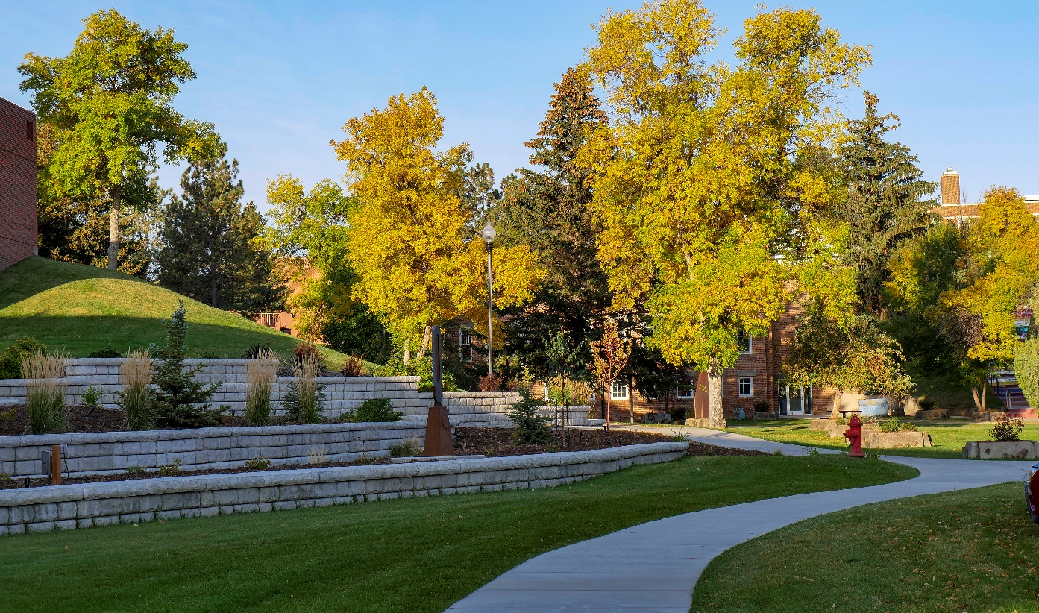
MSU- Northern’s Non-Discrimination Grievance Procedures

Required Information on Procedures for Reports of Domestic Violence, Dating Violence, Sexual Assault and Stalking

Procedures
All reports and complaints of violation of MSU-Northern’s sexual misconduct policy, specifically including domestic violence, dating violence, sexual assault, and stalking, are considered in accordance with MSU-Northern’s Discrimination Grievance Procedure, found online at (https://www.msun.edu/admin/policies/1000/1001-7-Procedures.aspx).

These procedures include the following:
- A prompt, fair, and impartial investigation and resolution of such reports and complaints;
- A process conducted by officials who receive annual training on the issues related to sexual misconduct, domestic violence, and stalking, including how to conduct investigations and hearings which protect the safety of victims and promotes accountability;
- A process in which the accusing party and the accused have the same opportunities to participate in the process, including the right to be accompanied by an adviser and the right to any appeal;
- Policy violations are established when the evidence shows that it is more likely than not the proscribed conduct occurred (referred to as a “preponderance of the evidence standard”);
- The outcome of the process, including the determination of whether a policy violation occurred and the sanction imposed, will be disclosed to both the accusing party and the accused; and
- A written statement will be provided to any student or employee victim of sexual misconduct, dating violence, domestic violence, or stalking providing an explanation of their rights under the Discrimination Grievance Procedure.

Sanctions
If a student is found to have violated MSU’s sexual misconduct policy, to include domestic violence, dating violence, sexual assault, and stalking, and, thus, the Student Conduct Code, the university may impose sanctions against the student.

For further information regarding sanctions, please review the MSU-Northern Student Code of Conduct (http://www.msun.edu/admin/policies/600/601-3.aspx). If an employee is found to have violated the University’s discrimination policy, sanctions may be imposed in accordance with the applicable University personnel policy and Collective Bargaining Agreements.

Disclosure of Student Disciplinary Proceedings
The Discrimination Grievance Procedure provides that MSU-Northern will disclose the outcome of any student disciplinary action related to violation of the Discrimination Policy to both the charging student and the charged student. The outcome of a proceeding means the institution’s final determination regarding whether there was a violation of the Discrimination Policy and the sanction imposed.

Retaliation Prohibited
The Discrimination Policy prohibits retaliation against any person for reporting concerns, or filing, testifying, assisting or participating in any manner in investigations or proceedings involving allegations of violation of the Discrimination Policy. Retaliation is subject to the same discrimination grievance procedure and the same potential sanctions.

The Discrimination Grievance Procedure can be found in its entirety online at https://www.msun.edu/hr/titleix/index.aspx.

Education and Outreach

In an effort to reduce the risk of sexual violence, including the crime of rape, sexual assault, sexual harassment, stalking, dating violence, and domestic violence occurring among our students, MSU-Northern utilizes a range of campaigns, strategies, and initiatives to promote awareness, educational, risk reduction, and prevention programming.

MSU-Northern offers programming each year to identify and prevent domestic violence, dating violence, sexual assault, and stalking. Educational programs are offered to raise awareness for all incoming students and employees. Students participate in educational programming during new student summer orientation and throughout an incoming student’s first semester. New employees attend New Employee Orientation. All employees attend Mandatory Reporter Training each year. The University engages in comprehensive, intentional, and integrated programming, initiatives, strategies, and campaigns intended to end dating violence, domestic violence, sexual assault and stalking that:

- Are culturally relevant, inclusive of diverse communities and identities, sustainable, responsive to community needs, and informed by research, or assessed for value, effectiveness, or outcome; and
- Consider environmental risk and protective factors as they occur on the individual, relationship, institutional, community and societal levels.

Educational programming consists of primary prevention and awareness programs for all incoming students and new employees and ongoing awareness and prevention campaigns for students and employees. Programs and other campaigns offered throughout the year to all students and employees include strong messages regarding not just awareness, but also primary prevention (including normative messaging, environmental management, and bystander intervention), and discuss institutional policies.

A description of safe and positive options for bystander intervention is also provided. Bystander intervention means safe and positive options that may be carried out by an individual or individuals to prevent harm or intervene when there is a risk of dating violence, domestic violence, sexual assault or stalking. Bystander intervention includes recognizing situations of potential harm, understanding institutional structures and cultural conditions that facilitate violence, overcoming barriers to intervening, identifying safe and effective intervention options, and taking action to intervene.

Programs also offer information on risk reduction that strives to empower victims, how to recognize warning signals and how to avoid potential attacks and do so without victim-blaming approaches.

The programming also includes information regarding:
- procedures victims should follow if a crime of domestic violence, dating violence, sexual
assault and stalking occurs;
- how the institution will protect the confidentiality of victims and other necessary parties;
- existing counseling, health, mental health, victim advocacy, legal assistance, visa and immigration assistance, student financial aid, and other services available for victims, both within the institution and in the community;
- options for, available assistance in, and how to request changes to academic, living, transportation, and working situations or protective measures;
- procedures for institutional disciplinary action in cases of alleged dating violence, domestic violence, sexual assault, or stalking.

Reducing Risk On-Campus and In Our Community

We all have a responsibility to keep our campus and community safe. Being aware of different strategies and taking action when you feel someone is unsafe can help someone get out of a potentially dangerous situation. Look out for one another. If someone looks uncomfortable or afraid, check in, find someone who knows the person who can help, or call someone in a position of authority to step in.

If you ever are unsure about a situation you are in, trust your instincts. Make an excuse to leave, ask for help, or even just walk away. Be true to who you are and what you value most. You aren’t obligated to do something you don’t want to do, and a simple, “I don’t want to” is a good enough reason. If you’re feeling pressured in a situation, or if you’re afraid a blunt “no” will make the situation worse, don’t hesitate to make an excuse or even lie if that’s what you need to do to get out of the situation.

With no intent to victim blame and recognizing that only abusers are responsible for their abuse, the following are some strategies to reduce one’s risk of sexual assault or harassment (taken from Rape, Abuse, & Incest National Network, www.rainn.org):

- Be aware of your surroundings. Knowing where you are and who is around you may help you to find a way to get out of a bad situation.

- Try to avoid isolated areas. It is more difficult to get help if no one is around.

- Walk with purpose. Even if you don’t know where you are going, act like you do.

- Trust your instincts. If a situation or location feels unsafe or uncomfortable, it probably isn’t the best place to be.

- Try not to load yourself down with packages or bags as this can make you appear more vulnerable.

- Make sure your cell phone is with you and charged and that you have cab money.

- Don’t allow yourself to be isolated with someone you don’t trust or someone you don’t know.

- Avoid putting music headphones in both ears so that you can be more aware of your surroundings, especially if you are walking alone.

- When you go to a social gathering, go with a group of friends. Arrive together, check in with each other throughout the evening, and leave together. Knowing where you are and who is around you may help you to find a way out of a bad situation.

- Trust your instincts. If you feel unsafe in any situation, go with your gut. If you see something suspicious, contact law enforcement .

- Don’t leave your drink unattended while talking, dancing, using the restroom, or making a phone call. If you’ve left your drink alone, just get a new one.

- Don’t accept drinks from people you don’t know or trust. If you choose to accept a drink, go with the person to the bar to order it, watch it being poured, and carry it yourself. At parties, don’t drink from the punch bowls or other large, common open containers.

- Watch out for your friends, and vice versa. If a friend seems out of it, is way too intoxicated for the amount of alcohol they’ve had, or is acting out of character, get him or her to a safe place immediately.

- If you suspect you or a friend has been drugged, contact law enforcement immediately (local authorities can be reached by calling 911 in most areas of the U.S.). Be explicit with doctors so they can give you the correct tests (you will need a urine test and possibly others).

- If you need to get out of an uncomfortable or scary situation here are some things that you can try:
  - Remember that being in this situation is not your fault. You did not do anything wrong; it is the person who is making you uncomfortable that is to blame.

  - Be true to yourself. Don’t feel obligated to do anything you don’t want to do. Do what feels right to you and what you are comfortable with.

  - Have a code word with your friends or family so that if you don’t feel comfortable you can call them and communicate your discomfort without the person you are with knowing. Your friends or family can then come to get you or make up an excuse for you to leave.

  - Lie. If you don’t want to hurt the person’s feelings it is better to lie and make up a reason to leave than to stay and be uncomfortable, scared, or worse. Some excuses you could use are:
    - needing to take care of a friend or family member,
    - not feeling well,
    - having somewhere else that you need to be, etc.

  - Try to think of an escape route. How would you try to get out of the room? Where are the doors? Windows? Are there people around who might be able to help you? Is there an emergency phone nearby?

  - If you and/or the other person have been drinking, you can say that you would rather wait until you both have your full judgment before doing anything you may regret later.

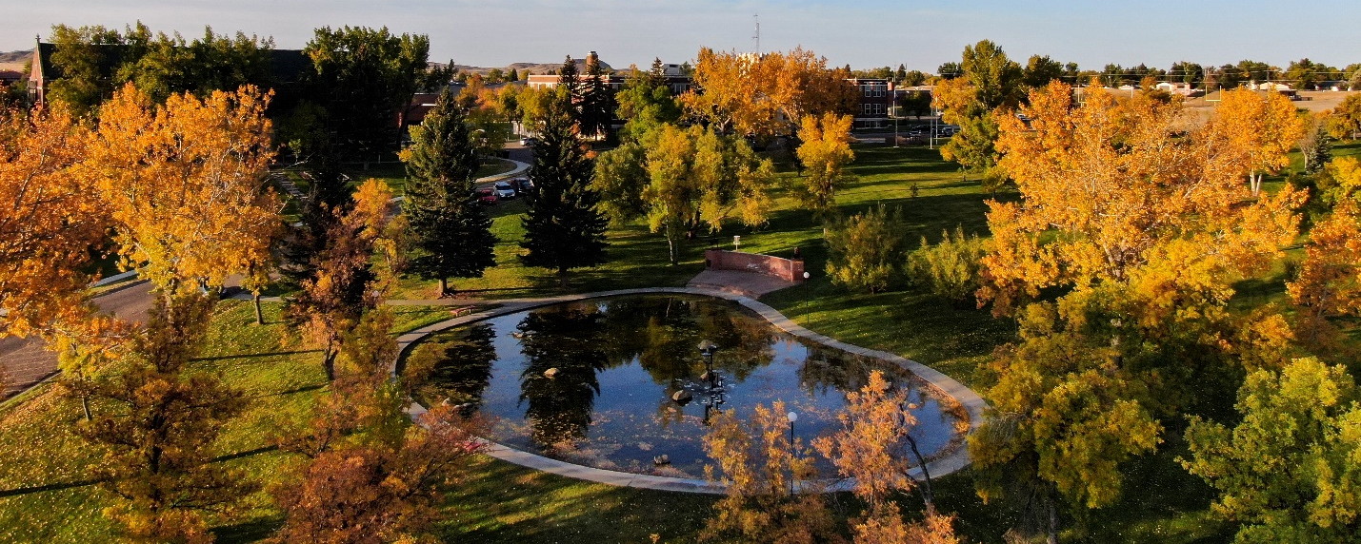

Sexual or Violent Offender List (Montana State Sex Offender Registry)

The Campus Sex Crimes Prevention Act (CSPA) of 2000 is a federal law that provides for the tracking of convicted sex offenders enrolled at, or employed by, institutions of higher education. The CSPA is an amendment to the Jacob Wetterling Crimes against Children and Sexually Violent Offender Act. Under the Campus Sex Crime Prevention Act, persons are required to register in the state in which the offender works or is a student. In 1989 the Montana Department of Justice created the Sexual and Violent Offender Registry as a valuable resource for Montanans to protect their families against sexual or violent offenders. Under 46-23508 of the Montana Code Annotated, at a minimum, the public is entitled to the following information about all sexual and violent offenders: the name and address of any registered offender in Montana; any offender registration information relevant to the public regarding an offender who a law enforcement agency has determined is a risk to a community’s safety; and the date of an offender’s sentence.

Convicted sex offenders must register with the local law enforcement agency in the jurisdiction where the offender resides. Each time the offender moves or changes jobs, the offender must notify the local law enforcement agency.

Additionally, the CSPA (2000) requires that:
- registered sex offenders provide notice, as required under State law, of each institution of higher education where they are employed or enrolled;
- states must make this information available to a law enforcement agency where the institution of higher education is located; and
- institutions of higher education must advise the campus community where the information on registered sex offenders can be obtained.

For more information on sexual and violent offenders in Montana, visit:

University’s website (https://www.msun.edu/stuaffairs/campussafety/
Montana Department of Justice https://app.doj.mt.gov/apps/svow/
Sexual Violent Offender Registration (https://app.doj.mt.gov/apps/svow/

University Policies on Alcohol and Other Drugs

Policies

MSU-Northern policies related to alcohol and drugs promote a healthy campus environment. The policies conform to the requirements of the Drug Free Schools and Communities Act, [20. U.S.C. 1145g, (34 CFR Part 86)] and the Montana Board of Regents Policy 503.1, Alcoholic Beverages (https://mus.edu/borpol/bor500/503-1.pdf).

MSU-Northern policies relating to alcohol and drugs:

• Drug Abuse and Prevention: https://www.msun.edu/admin/policies/1000/1003.aspx
• Alcoholic Beverages: https://www.msun.edu/admin/policies/1000/1003-1.aspx
• Drug Free Workplace: https://www.msun.edu/admin/policies/1000/1003-2.aspx

MSU-Northern’s policy prohibits unlawful possession, consumption, use, distribution or sale of illicit drugs and alcohol by students and employees on campus property.

Upon request, the Office of Human Resources shall provide confidential referrals to drug counseling or rehabilitative programs and shall counsel employees on available assistance under the group insurance plan. Members of the campus community may also seek referral information for our MSU-Northern Counselor and MUS Wellness.

Alcohol

Montana Board of Regents Policy
The Montana Board of Regents (Policy 503.1) provides that consumption of alcoholic beverages is permitted on property belonging to the Montana University System only as follows:

- Within student living quarters, consumption of alcohol is allowed only by persons of legal age. Legal consumption by students in student living quarters shall not interfere with the rights of other residents and their guests or cause the normal operation of residence halls/student housing to be disrupted.
- Within approved areas on campus property that are used or rented as approved by the MSU-Northern Chancellor.

Events
MSU-Northern has established procedures for obtaining approval to serve alcohol at campus events. All events involving alcohol on campus must receive approval from the Chancellor (or Chancellor’s designee). Additional information related to policy, procedure, and requirements for events approved to serve alcohol can be found online at http://www.msun.edu/admin/policies/1000/1003-1.aspx (Alcoholic Beverages) and http://www.msun.edu/admin/policies/900/903-1.aspx (University Property and Facilities Rental).

Residence Halls and Student Family Housing
MSU-Northern’s policy allows the possession and consumption of alcohol in the privacy of a student’s room or individual student family housing unit, in accordance with applicable State law (legal drinking age in Montana is 21). However, the university does not allow alcoholic beverages to be consumed in public areas such as hallways and lounges.

Associated Students of Montana State University-Northern (ASMSUN), Departmental and Other Registered Student Organizations
MSU-Northern’s Alcohol Policy also regulates the use of alcohol at gatherings or events sponsored by ASMSUN, registered student organizations, and other organized student groups.

Such groups must follow MSU-Northern’s policies and procedures governing the use of alcohol at events and must receive prior approval in accordance with Campus Policy 1003.1 (Alcoholic Beverages), which can be found at http://www.msun.edu/admin/policies/1000/1003-1.aspx. No organizational or ASMSUN funds may be used to buy alcohol.

Drug-Free Workplace

MSU-Northern’s Drug Free Workplace Policy (http://www.msun.edu/admin/policies/1000/1003-2.aspx) prohibits the illegal manufacture, distribution and sale, possession or use of a controlled substance by students, faculty and staff in the workplace or while conducting University business. Students in violation of the policy may be required by the university to receive treatment, change housing assignments, or to be suspended or expelled. Faculty and staff in violation of this policy may be required by the university to receive treatment. The University may exercise disciplinary actions against faculty and staff in violation of the policy up to and including termination.

Upon request, the Office of Human Resources shall provide confidential referrals to drug counseling or rehabilitative programs and shall counsel employees on available assistance under the group insurance plan. Members of the campus community may also seek referral information for our MSU-Northern Counselor and MUS Wellness.

Resources

Abusive use of alcohol and/or the use of illicit drugs or misuse of prescription drugs can be detrimental to the physical and mental health of students and members of the surrounding community. The various risks are classified and described in this section of the Report.

Second-Hand Effects
“Second hand” effects result from other peoples' drinking or drug use and are often experienced by students who choose not to use drugs or alcohol in a high-risk manner. These concerns are typically most prominent among students living in close quarters (e.g., residence halls). Disruptions of sleep or studying, property damage, feelings of safety and security, strained social connections, and decreased enjoyment of and enthusiasm for the campus experience are often side effects that impact members of the campus community, as well as institutional neighbors and partners in the larger communities in which our institutions exist.

Risks Associated with Dependency or Addiction
For some students, substance use escalates to dependency. Adverse effects of dependency can include illnesses such as liver disease, peripheral neuropathy, and cerebella degeneration.
Additional health risks to students with chemical or psychological dependency include the personal problems listed above in addition to blackouts, alcoholic hallucinations, and delirium tremens. Prescribed medications and illicit drugs can be abused with or without dependency, leading to potential dependency, acute intoxication (can include depression or euphoria, altered time perception, impairment of immediate memory, overdose, stupor, shock, coma or death), acute withdrawal, psychosis, or aggravation of existing mental illness.

Symptoms of dependency include the following:
- psychological craving: intense feeling of need for the drug which may be accompanied with antisocial behavior involved in the procurement of the substance;
- physiological dependence: withdrawal symptoms are displayed when use of the substance is discontinued; and
- tolerance: need to increase the dose of the substance to obtain the desired effects.

MSU-Northern’s Residential Education Office sponsors educational programs regarding alcohol and drug use. All campus community members are welcome to attend. Services in the Havre area for alcoholism information and treatment include:
- Alcoholics Anonymous (888) 607-2000
- Alcohol & Drug Help Line (855) 682-7093.

An employee assistance program (EAP) is also available to provide information or confidential referral to drug and/or alcohol counseling or rehabilitation programs. An employee wishing to access the services may go to: http://wellness.mus.edu/. Employees needing help in dealing with drug/alcohol problems or information on insurance coverage for treatment and rehabilitation programs may also contact the Office of Human Resources at (406) 265-3789.

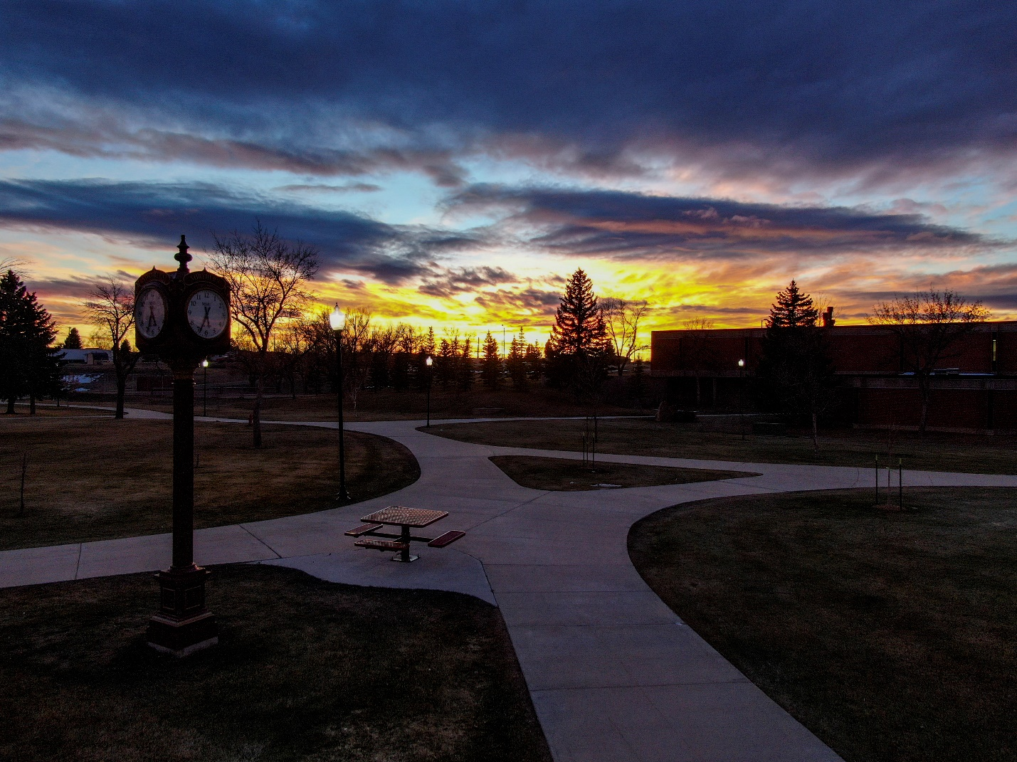

Preparation of the Annual Disclosure of Clery Crime Statistics

The University prepares this report to comply with the Jeanne Clery Disclosure of Campus Security and Crime Statistics Act. The Dean of Students compiles crimes reported to the campus security authorities that were reported to them the previous calendar year. By October 1st of each year, a notice is emailed to all faculty, staff, and students that provides a direct link to the MSU-Northern website containing the Clery Act report. Hard copies of the report may be obtained by request through the Dean of Students Office.

The procedures for preparing the annual disclosure of crime statistics include reporting statistics to the University community obtained from the Havre Police Department and Campus Security Authorities (CSAs). For statistical purposes, crime statistics reported to any of these sources are recorded in the calendar year the crime was reported.

All of the statistics are gathered, compiled, and reported to the University community via this report, which is published by the Dean of Students Office. The MSU-Northern Dean of Students submits the annual crime statistics published in this Report to the Department of Education (ED). The statistical information gathered by the Department of Education is available to the public through the Department of Education’s website.

Under the Clery Act, MSU-Northern is required to report annual crime statistics showing reported occurrences of specific types of crime for the benefit of current/prospective students and current/prospective employees.

Crimes reported under the Silent Witness Program are included in the annual disclosure of crime statistics. Statistics pertaining to referrals for disciplinary action reflect those incidents of alcohol, drugs, and weapons violations that were referred to the Dean of Students or Residential Education Offices for student disciplinary action. The Dean of Students’ Office has included information for public property and non-campus buildings or property, per the Havre Police Department.

Clery Geography and Maps

Clery Definitions

The following definitions have been identified by the Clery Act and serve to guide our efforts when determining what statistics are included in the Annual Security and Fire Safety Report.

On-Campus
Any building or property owned or controlled by an institution within the same reasonably contiguous geographic area and used by the institution in direct support of, or in a manner related to, the institution’s educational purposes, including residence halls.

Also included is any building or property that is within or reasonably contiguous to the area identified in paragraph (1) of this definition, that is owned by the institution but controlled by another person, is frequently used by students, and supports institutional purposes (such as a food or other retail vendor).

On-Campus Student Housing
Any student housing facility that is owned or controlled by the institution or is located on property that is owned or controlled by the institution and is within the reasonably contiguous geographic area that makes up the campus is considered an on-campus student housing facility.

Non-campus
Any building or property owned or controlled by a student organization that is officially recognized by the institution; or any building or property owned or controlled by an institution that is used in direct support of, or in relation to, the institution’s educational purposes, is frequently used by students, and is not within the same reasonably contiguous geographic area of the institution.

For the purposes of this report, Non-campus includes the Chancellor’s House (1325 11th Ave, Havre, MT), which is used primarily for events and activities.

Public Property
All public property, including thoroughfares, streets, sidewalks, and parking facilities, that is
within the campus, or immediately adjacent to and accessible from the campus.

Separate Campus
is defined as "a separate location that the institution owns or controls, is not reasonable geographically contiguous with the main campus, has an organized program of study, and there is at least one person on site acting in an administrative capacity."

Off Campus Trips
"If your institution sponsors students on an overnight trip every year and the students stay in the same hotel each year, you must include portions of the hotel in your non-campus geography. For example, students in the debate club take a trip to Washington, D.C. and stay at the same hotel every year. You must include in your statistics any crimes that occur in the rooms used by your students and any common areas used to access the rooms (lobby, elevators, etc.) for the times and dates specified in the rental agreement. Note that what matters here is repeated use of a location that is owned or controlled by the institution, not the number of days it is used or whether it is used by the same students or different students.

Short-stay “away” trips
If your institution sponsors short-stay “away” trips of more than one night for its students, all locations used by students during the trip, controlled by the institution during the trip and used to support educational purposes should be treated as non-campus property. An example is a three-week marine biology study trip to Florida. Any classroom or housing space specified in the agreement between the institution and a third-party providing the space would be non-campus property. If your institution has entered into a written agreement with a third-party contractor to arrange housing and/or classroom space for a school-sponsored trip or study program (either domestic or foreign), it is assumed that the contractor is operating on behalf of the school as the school’s agent, putting the institution in control of this space. However, if your institution (or a contracted third party) does not have an agreement for the space used, your institution is not in control of the space and you are not required to count it. For example, there are some situations, such as sports tournaments, for which the host institution makes all of the housing arrangements for visiting students. In these situations, the visiting institutions do not have a written agreement for the use of space and are not required to disclose crime statistics for the housing in which their students are located. However, the host institution would be responsible for disclosing crime statistics for the housing since they hold the agreement for the housing.

Study abroad programs
If your institution sends students to study abroad at a location or facility that you don’t own or control, you don’t have to include statistics for crimes that occur in those facilities. However, if your institution rents or leases space for your students in a hotel or student housing facility, you are in control of that space for the time period covered by your agreement. Host family situations do not normally qualify as non-campus locations unless your written agreement with the family gives your school some significant control over space in the family home."

Clery Geography

The following maps provide outlines of our On-Campus, Public Property, and Non-campus locations as identified above. The blue highlighted area in each map identifies the indicated location(s).

On-Campus and Public Property

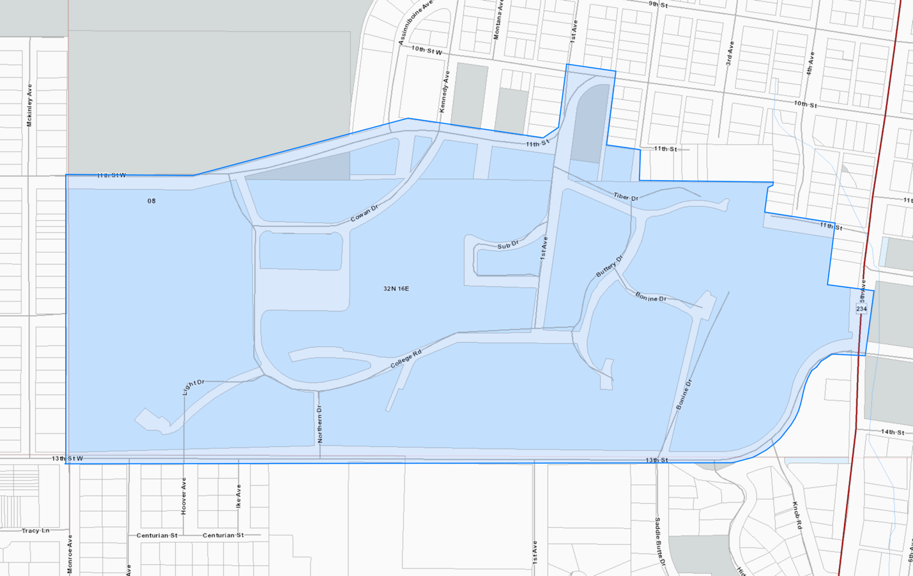
MSU-Northern
Campus

Non-campus Property | 1325 11th Ave, Havre, MT
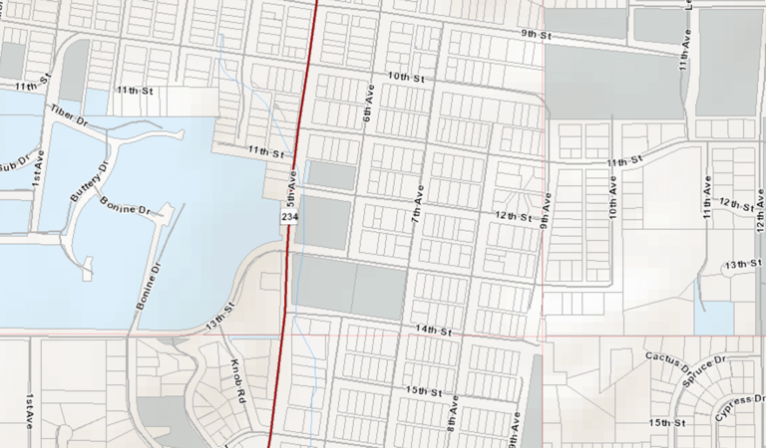
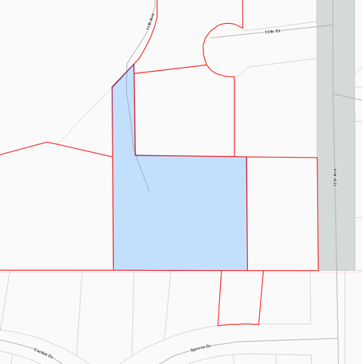
MSU-Northern
Campus

Campus Map

The following campus map may assist in identifying campus buildings and grounds, which make up the On-Campus locations included in this report.

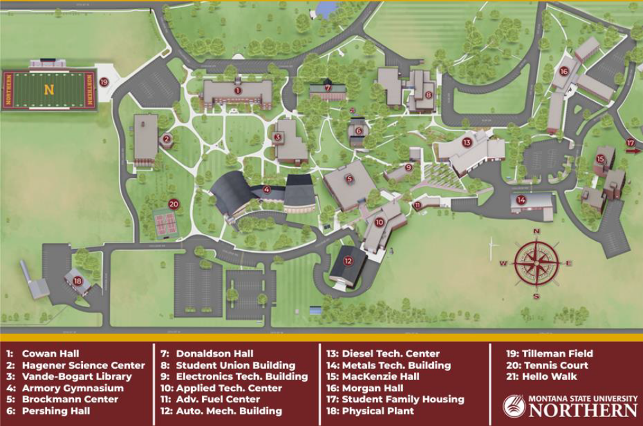

*Please note that this campus map is not inclusive of all campus buildings or grounds. The map is intended as a reference tool for readers of this report, but is not indicative of all Clery reporting boundaries. Clery geography is most clearly defined on the previous maps provided above.
MSU-Northern Crime Statistics | 2023-2025 CLERY DATA

The following crime statistics are for selected crimes that have been reported to appropriate and corresponding police agencies or to campus security authorities based on our Clery geography. The statistics reported for the sub-categories on liquor laws, drug laws, and weapons offenses represented the number of people arrested or referred to campus judicial authorities for respective violations, not the number of offenses documented.

Criminal Offenses  (Reported by Hierarchy) | On-Campus |  |  | On-Campus Student Housing |  |  | Non-campus |  |  | Public Property
Criminal Offenses  (Reported by Hierarchy) | 2023 | 2024 | 2025 | 2023 | 2024 | 2025 | 2023 | 2024 | 2025 | 2023 | 2024 | 2025
Murder/Non-Negligent Manslaughter | 0 | 0 | 0 | 0 | 0 | 0 | 0 | 0 | 0 | 0 | 0 | 0
Manslaughter by Negligence | 0 | 0 | 0 | 0 | 0 | 0 | 0 | 0 | 0 | 0 | 0 | 0
Rape | 0 | 0 | 0 | 0 | 0 | 0 | 0 | 0 | 0 | 0 | 0 | 0
Fondling | 0 | 0 | 0 | 0 | 0 | 0 | 0 | 0 | 0 | 0 | 0 | 0
Incest | 0 | 0 | 0 | 0 | 0 | 0 | 0 | 0 | 0 | 0 | 0 | 0
Statutory Rape | 0 | 0 | 0 | 0 | 0 | 0 | 0 | 0 | 0 | 0 | 0 | 0
Robbery | 0 | 0 | 0 | 0 | 0 | 0 | 0 | 0 | 0 | 0 | 0 | 0
Aggravated Assault | 0 | 0 | 1 | 0 | 0 | 1 | 0 | 0 | 0 | 0 | 0 | 0
Burglary | 0 | 0 | 0 | 0 | 0 | 0 | 0 | 0 | 0 | 0 | 0 | 0
Motor Vehicle Theft | 1 | 0 | 0 | 1 | 0 | 0 | 0 | 0 | 0 | 0 | 0 | 0
Arson | 0 | 0 | 0 | 0 | 0 | 0 | 0 | 0 | 0 | 0 | 0 | 0

VAWA Offenses | On-Campus |  |  | On-Campus Student Housing |  |  | Non-campus |  |  | Public Property
VAWA Offenses | 2023 | 2024 | 2025 | 2023 | 2024 | 2025 | 2023 | 2024 | 2025 | 2023 | 2024 | 2025
Domestic Violence | 0 | 0 | 1 | 0 | 0 | 1 | 0 | 0 | 0 | 0 | 0 | 0
Dating Violence | 0 | 0 | 0 | 0 | 0 | 0 | 0 | 0 | 0 | 0 | 0 | 0
Stalking | 0 | 0 | 0 | 0 | 0 | 0 | 0 | 0 | 0 | 0 | 0 | 0

Arrests | On-Campus |  |  | On-Campus Student Housing |  |  | Non-campus |  |  | Public Property
Arrests | 2023 | 2024 | 2025 | 2023 | 2024 | 2025 | 2023 | 2024 | 2025 | 2023 | 2024 | 2025
Weapons Law Arrests | 0 | 0 | 0 | 0 | 0 | 0 | 0 | 0 | 0 | 0 | 0 | 0
Drug Law Arrests | 10 | 0 | 0 | 10 | 0 | 0 | 0 | 0 | 0 | 0 | 0 | 0
Liquor Law Arrests | 0 | 0 | 3 | 0 | 0 | 3 | 0 | 0 | 0 | 0 | 0 | 0

Disciplinary Referrals | On-Campus |  |  | On-Campus Student Housing |  |  | Non-campus |  |  | Public Property
Disciplinary Referrals | 2023 | 2024 | 2025 | 2023 | 2024 | 2025 | 2023 | 2024 | 2025 | 2023 | 2024 | 2025
Weapons Law Violations | 1 | 0 | 0 | 1 | 0 | 0 | 1 | 0 | 0 | 1 | 0 | 0
Drug Law Violations | 1 | 1 | 7 | 1 | 1 | 7 | 0 | 0 | 0 | 0 | 0 | 0
Liquor Law Violations | 5 | 6 | 6 | 5 | 6 | 6 | 0 | 0 | 0 | 0 | 0 | 0
Hazing | N/A | N/A | 0 | N/A | N/A | 0 | N/A | N/A | 0 | N/A | N/A | 0

Unfounded Crimes

Year | Description
2025 | No unfounded crimes to report.
2024 | No unfounded crimes to report.
2023 | No unfounded crimes to report.

Hate Crimes by Category and Bias

Year | Description
2025 | No hate crimes to report.
2024 | No hate crimes to report.
2023 | No hate crimes to report.

Definition of Crime Categories Under Federal Law

Criminal Offenses are defined as outlined by the U.S. Department of Justice, FBI National Incident- Based Reporting System. For the purposes of complying with the requirements of 34 CFR 668.41, and incident meeting these definitions is considered a crime for the purpose of Clery Act reporting.

- Murder & Non-Negligent Manslaughter: The willful (non- negligent) killing of one human being by another. Any death caused by injuries received in a fight, argument, quarrel, assault, or commission of a crime is classified as murder and non- negligent manslaughter.
- Manslaughter by Negligence: Is defined as the killing of another person through gross negligence. Deaths of persons due to their own negligence, accidental deaths not resulting from gross negligence, and traffic fatalities, are not included in the category Manslaughter by Negligence.
- Sexual Assault: An offense that meets the definition of rape, fondling, incest, or statutory rape as used in the FBI’s Uniform Crime Reporting (UCR) program. Per the National Incident- Based Reporting System User Manual from the FBI UCR Program, a sex offense is “any sexual act directed against another person, without the consent of the victim, including instances where the victim if incapable of giving consent.”
  - Rape: The penetration, no matter how slight, of the vagina or anus with any body part or object, or oral penetration by a sex organ of another person, without the consent of the victim.
  - Fondling: The touching of the private body parts of another person for the purpose of sexual gratification, without the consent of the victim, including instances where the victim is incapable of giving consent because of his/her age or because of his/her temporary or permanent mental or physical incapacity. (Because there is no penetration in fondling, this offense will not convert to the SRS as Rape)
  - Incest: sexual intercourse between persons who are related to each other within the degrees wherein marriage is prohibited by law.
  - Statutory Rape: sexual intercourse with a person who is under the statutory age of consent.
- Robbery: The taking, or attempted taking, of anything of value from one person by another, in which the offender uses force or the threat of violence.
- Aggravated Assault: Aggravated assault is an unlawful attack by one person upon another for the purpose of inflicting severe or aggravated bodily injury. This type of assault usually is accompanied by the use of a weapon or by means likely to produce death or great bodily harm.
- Burglary: The unlawful entry into a building or other structure with the intent to commit a felony or a theft.
- Motor-Vehicle Theft: The theft or attempted theft of a motor vehicle, including automobiles, trucks, motorcycles, and mopeds.
- Arson: The willful or malicious burning or attempt to burn, with or without intent to defraud, a dwelling house, public building, motor vehicle, or aircraft, personal property of another, etc.
- Domestic Violence: Includes felony or misdemeanor crimes of violence committed by a current or former spouse of the victim, by a person with whom the victim shares a child in common, by a person who is cohabitating with or has cohabitated with the victim as a spouse or intimate partner, by a person similarly situated to a spouse of the victim under the domestic or family violence laws of the jurisdiction in which the crime of violence occurred, or by any other person against an adult or youth victim who is protected from that persons acts under the domestic or family violence laws of the jurisdiction in which the crime of violence occurred.
- Dating Violence: Violence committed by a person who is or has been in a social relationship of a romantic or intimate nature with the victim; and, where the existence of such a relationship shall be determined by the victim with consideration of the following factors: (1) the length of the relationship, (2) the type of relationship, (3) the frequency of the interaction between the persons involved in the relationship.
- Stalking: Engaging in a course of conduct directed at a specific person that would cause a reasonable person to fear for the person’s safety or the safety of others; or to suffer substantial emotional distress. Course of conduct means two or more acts, including, but not limited to, acts which the stalker directly, indirectly, or through third parties, by any action, method, device, or means follows, monitors, observes, surveils, threatens, or communicates to or about, a person, or interferes with a person’s property.
  - Reasonable person means a reasonable person under similar circumstances and with similar identities to the victim.
  - Substantial emotional distress means significant mental suffering or anguish that may, but does not necessarily, require medical or other professional treatment or counseling.
- Liquor-Law Violations: The violation of laws or ordinances prohibiting: the manufacture, sale, transporting, furnishing, possessing of intoxicating liquor; maintaining unlawful drinking places; bootlegging; operating a still; furnishing liquor to a minor or intemperate person; underage possession; using a vehicle for illegal transportation of liquor; drinking on a train or public conveyance; and all attempts to commit any of the aforementioned offenses.
  - Drunkenness and driving under the influence are not included in this definition.
- Drug-Law Violations: Violations of State and local laws relating to the unlawful possession, sale, use, growing, manufacturing, and making of narcotic drugs. The relevant substances include: opium or cocaine and their derivatives (morphine, heroin, codeine); marijuana; synthetic narcotics (Demerol, methadone); and dangerous non-narcotic drugs (barbiturates, Benzedrine).
- Weapons-Law Violations: The violation of laws or ordinances dealing with weapon offenses, regulatory in nature, such as: manufacture, sale, or possession of deadly weapons; carrying deadly weapons, concealed or openly; furnishing deadly weapons to minors; aliens possessing deadly weapons; and all attempts to commit any of the aforementioned offenses.

Categories of Prejudice
Hate Crime is defined as a criminal offense committed against a person or property that is motivated, in whole or in part, by the offender’s bias. Bias is a preformed negative opinion or attitude toward a group of persons based on their race, gender, religion, national origin, sexual orientation, gender identity, ethnicity or disability.

For Clery Act reporting purposes, hate crimes include any offense in the following list that is motivated by bias:
- Murder and Non-negligent manslaughter
- Sex Offense
- Robbery
- Aggravated Assault
- Burglary
- Motor Vehicle Theft
- Arson
- Destruction/Damage/Vandalism to Property
- Intimidation
- Larceny/Theft
- Simple Assault

Hate Crime Bias
- Race
- Gender
- Religion
- National Origin
- Sexual Orientation
- Gender Identity
- Ethnicity
- Disability

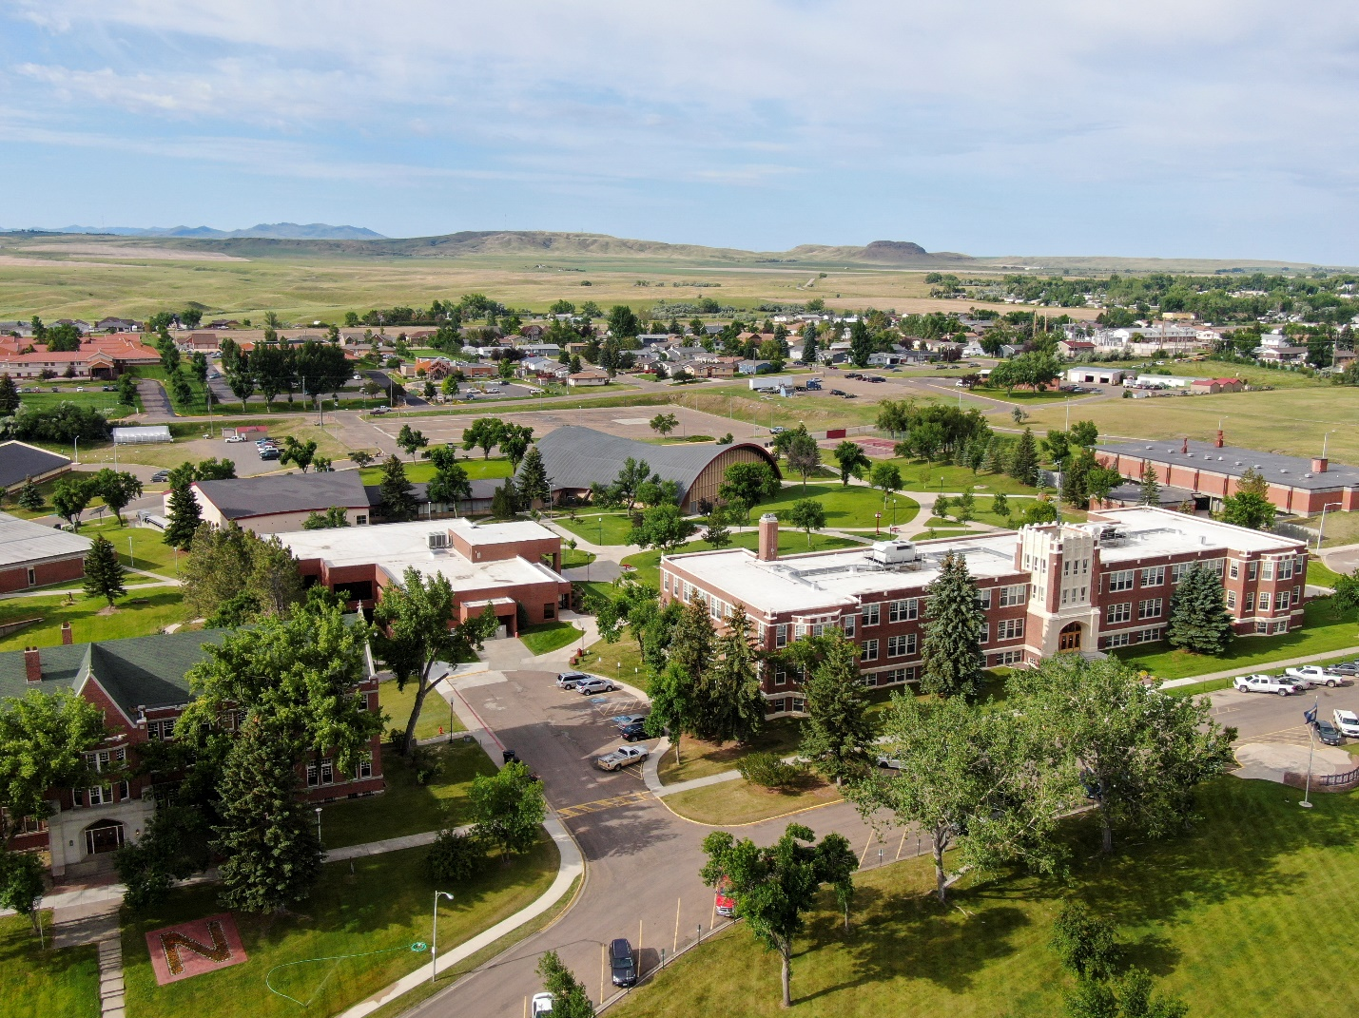

Definition of Crime Categories Under Montana Law

Domestic Violence, Dating Violence, Sexual Assault and Stalking

The terms Domestic Violence, Dating Violence, Sexual Assault, Stalking and Consent are defined in the applicable jurisdiction as outlined by Montana Code Annotated (MCA) 2019, Title 45. Crimes, Chapter 5. Offenses Against the Person, Part 5. Sexual Crimes.

- Domestic Violence: The state of Montana does not have a definition of domestic violence.
- Dating Violence: The state of Montana does not have a definition of dating violence.
- Sexual Assault: The state of Montana defines sexual assault as follows:
Montana Code Annotated (MCA) 40- 15-116. Definitions: As used in 40-15-115 through 40-15-121, the following definitions apply: (5) “Sexual assault” means sexual assault as defined in 45-5-502, sexual intercourse without consent as defined in 45-5-503, incest as defined in 45-5-507, or sexual abuse of children as defined in 45-5- 625.

45-5-502. Sexual Assault
- A person who knowingly subjects another person to any sexual contact without consent commits the offense of sexual assault.
  - On a first conviction for sexual assault, the offender shall be fined an amount not to exceed $500 or be imprisoned in the county jail for a term not to exceed 6 months, or both.
  - On a second conviction for sexual assault, the offender shall be fined an amount not to exceed $1,000 or be imprisoned in the county jail for a term not to exceed 1 year, or both.
  - On a third and subsequent conviction for sexual assault, the offender shall be fined an amount not to exceed $10,000 or be imprisoned for a term not to exceed 5 years, or both.

- If the victim is less than 16 years old and the offender is 3 or more years older than the victim or if the offender inflicts bodily injury upon anyone in the course of committing sexual assault, the offender shall be punished by life imprisonment or by imprisonment in the state prison for a term of not less than 4 years, unless the judge makes a written finding that there is good cause to impose a term of less than 4 years and imposes a term of less than 4 years, or more than 100 years and may be fined not more than $50,000.

- An act “in the course of committing sexual assault” includes an attempt to commit the offense or flight after the attempt or commission.
a. Subject to subsections (5)(b) and (5)(f), consent is ineffective under this section if the victim is:
  - incarcerated in an adult or juvenile correctional, detention, or treatment facility or is on probation or parole and the perpetrator is an employee, contractor, or volunteer of the supervising authority and has supervisory or disciplinary authority over the victim, unless the act is part of a lawful search;
  - less than 14 years old and the offender is 3 or more years older than the victim;
  - receiving services from a youth care facility, as defined in 52-2-602, and the perpetrator:

    - has supervisory or disciplinary authority over the victim or is providing treatment to the victim; and
    - is an employee, contractor, or volunteer of the youth care facility; or

  - admitted to a mental health facility, as defined in 53-21-102, is admitted to a community- based facility or a residential facility, as those terms are defined in 53- 20-102, or is receiving community-based services, as defined in 53-20-102, and the perpetrator:

    - has supervisory or disciplinary authority over the victim or is providing treatment to the victim; and
    - is an employee, contractor, or volunteer of the facility or community-based service.

  - a program participant, as defined in 52-2-802, in a private alternative adolescent residential or outdoor program, pursuant to Title 52, chapter 2, part 8, and the perpetrator is a person associated with the program, as defined in 52-2-802;

  - the victim is a client receiving psychotherapy services and the perpetrator:

    - is providing or purporting to provide psychotherapy services to the victim; or
    - is an employee, contractor, or volunteer of a facility that provides or purports to provide psychotherapy services to the victim and the perpetrator has supervisory or disciplinary authority over the victim;

  - a student of an elementary, middle, junior high, or high school, whether public or nonpublic, and the perpetrator is not a student of an elementary, middle, junior high, or high school and is an employee, contractor, or volunteer of any school who has ever had instructional, supervisory, disciplinary, or other authority over the student in a school setting.

Subsection (5)(a)(i) does not apply if one of the parties is on probation or parole and the other party is a probation or parole officer of the supervising authority and the parties are married to each other.

Subsections (5)(a)(iii) and (5)(a)(iv) do not apply if the individuals are married to each other and one of the individuals involved is a patient in or resident of a facility, is a recipient of community-based services, or is receiving services from a youth care facility and the other individual is an employee, contractor, or volunteer of the facility or community- based service.

45-5-220. Stalking – Exemption – Penalty
- A person commits the offense of stalking if the person purposely or knowingly engages in a course of conduct directed at a specific person and knows or should know that the course of conduct would cause a reasonable person to:

  - fear for the person’s own safety or the safety of a third person; or
  - suffer other substantial emotional distress.

- For the purposes of this section, the following definitions apply:
  - “Course of conduct” means two or more acts, including but not limited to acts in which the offender directly or indirectly, by any action, method, communication, or physical or electronic devices or means, follows, monitors, observes, surveils, threatens, harasses, or intimidates a person or interferes with a person’s property.
  - “Reasonable person” means a reasonable person under similar circumstances as the victim. This is an objective standard.
  - “Substantial emotional distress” means significant mental suffering or distress that may but does not necessarily require medical or other professional treatment or counseling.

- This section does not apply to a constitutionally protected activity.

- Except as provided in subsection (4)(b), for the first offense, a person convicted of stalking shall be imprisoned in the county jail for a term not to exceed 1 year or fined an amount not to exceed $1,000, or both.
  - For a second or subsequent offense within 20 years or for a first offense when the offender violated any order of protection, when the offender used force or a weapon or threatened to use force or a weapon, or when the victim is a minor and the offender is at least 5 years older than the victim, the offender shall be imprisoned in the state prison for a term not to exceed 5 years or fined an amount not to exceed $10,000, or both.
  - A person convicted of stalking may be sentenced to pay all medical, counseling, and other costs incurred by or on behalf of the victim as a result of the offense.

- Upon presentation of credible evidence of violation of this section, an order may be granted, as set forth in Title 40, chapter 15, restraining a person from engaging in the activity described in subsection (1).

- For the purpose of determining the number of convictions under this section, “conviction” means:
  - a conviction, as defined in 45-2-101, in this state;
  - a conviction for a violation of a statute similar to this section in another state; or
  - a forfeiture of bail or collateral deposited to secure the defendant’s appearance in court in this state or another state for a violation of a statute similar to this section, which forfeiture has not been vacated.

- Attempts by the accused person to contact or follow the stalked person after the accused person has been given actual notice that the stalked person does not want to be contacted or followed constitutes prima facie evidence that the accused person purposely or knowingly followed, harassed, threatened, or intimidated the stalked person.

Consent

The State of Montana defines consent, in relation to sexual activity, with reference to sexual assault, in the applicable jurisdiction (Montana Code Annotated (MCA) 2019,
(45-5-501), as follows:
- The term “consent” means words or overt actions indicating a freely given agreement to have sexual intercourse or sexual contact and is further defined but not limited by the following:
  - an expression of lack of consent through words or conduct means there is no consent or that consent has been withdrawn;
  - a current or previous dating or social or sexual relationship by itself or the manner of dress of the person involved with the accused in the conduct at issue does not constitute consent; and
  - lack of consent may be inferred based on all of the surrounding circumstances and must be considered in determining whether a person gave consent.

- Subject to subsections (1)(c) and (1)(d), the victim is incapable of consent because the victim is:
  - mentally defective or incapacitated; physically helpless; overcome by deception, coercion, or surprise; less than 16 years old.
  - As used in subsection (a), the term “force” means:

    - the infliction, attempted infliction or threatened infliction of bodily injury or the commission of a forcible felony by the offender; or
    - the threat of substantial retaliatory action that caused the victim to reasonably believe that the offender has the ability to execute the threat.

State of Montana Laws on Alcohol and Other Illegal Drugs

Underage Consumption of Alcohol

45-5-624. Possession of or unlawful attempt to purchase intoxicating substance.
A person under 21 years of age commits the offense of possession of an intoxicating substance if the person knowingly consumes or has in the person’s possession an intoxicating substance. A person may not be arrested for or charged with the offense solely because the person was at a place where other persons were possessing or consuming alcoholic beverages. A person does not commit the offense if the person consumes or gains possession of an alcoholic beverage because it was lawfully supplied to the person under 16-6-305 or when in the course of employment, it is necessary to possess alcoholic beverages.

Relevant Age | Offense Level | Penalty
Under 18 years of age who is convicted | 1st Offense | Shall be fined an amount not less than $100 and not to exceed $300 and:  - shall be ordered to perform 20 hours of community service;  - shall be ordered, and the person’s parent or parents or guardian shall be ordered, to complete and pay all costs of participation in a community-based substance abuse information course that meets the requirements of subsection (9), if one is available; and  - if the person has a driver’s license, must have the license confiscated by the court for 30 days, except as provided in subsection (2)(b).
Under 18 years of age who is convicted | 2nd Offense | Shall be fined an amount not less than $200 and not to exceed $600 and:  - shall be ordered to perform 40 hours of community service;  - shall be ordered, and the person’s parent or parents or guardian shall be ordered, to complete and pay all costs of participation in a community-based substance abuse information course that meets the requirements of subsection (9), if one is available;  - if the person has a driver’s license, must have the license confiscated by the court for 6 months, except as provided in subsection (2)(b); and  - shall be required to complete a chemical dependency assessment and treatment, if recommended, as provided in subsection (8).
Under 18 years of age who is convicted | 3rd or Subsequent Offense | Shall be fined an amount not less than $300 or more than $900 and:  - shall be ordered to perform 60 hours of community service,  - shall be ordered, and the person’s parent or parents or guardian shall be ordered, to complete and pay all costs of participation in a community-based substance abuse information course that meets the requirements of subsection (9), if one is available, and  - shall be required to complete a chemical dependency assessment and treatment, if recommended, as provided in subsection (8).  If the person has a driver’s license, the court shall confiscate the license for 6 months, except as provided in subsection (2)(b).
18 years of age or older who is convicted | 1st Offense | Shall be fined an amount not less than $100 or more than $300 and:  • shall be ordered to perform 20 hours of community service; and  • shall be ordered to complete and pay all costs of participation in a community-based substance abuse information course that meets the requirements of subsection (9).
18 years of age or older who is convicted | 2nd Offense | Shall be fined an amount not less than $200 or more than $600 and:  - shall be ordered to perform 40 hours of community service; and  shall be ordered to complete and pay for an alcohol information course at an alcohol treatment program that meets the requirements of subsection (9), which may, in the court’s discretion and on recommendation of a licensed addiction counselor, include alcohol or drug treatment, or both.
18 years of age or older who is convicted | 3rd or Subsequent Offense | Shall be fined an amount not less than $300 or more than $900, and:  - shall be ordered to perform 60 hours of community service;  - shall be ordered to complete and pay for an alcohol information course at an alcohol treatment program that meets the requirements of subsection (9), which may, in the sentencing court’s discretion and on recommendation of a licensed addiction counselor, include alcohol or drug treatment, or both; and  in the discretion of the court, shall be imprisoned in the county jail for a term not to exceed 6 months
A person under the age of 21 (Attempts to purchase an intoxicating substance) |  | A person convicted of attempt to purchase an intoxicating substance shall be fined an amount not to exceed $150 if the person was under 21 years of age at the time that the offense was committed and may be ordered to perform community service.

Medical Amnesty

45-5-624. Possession of or unlawful attempt to purchase intoxicating substance.

A person under 21 years of age may not be charged or prosecuted under subsection (1) if:
- the person has consumed an intoxicating substance and seeks medical treatment at a health care facility or contacts law enforcement personnel or an emergency medical service provider for the purpose of seeking medical treatment;
- the person accompanies another person under 21 years of age who has consumed an intoxicating substance and seeks medical treatment at a health care facility or contacts law enforcement personnel or an emergency medical service provider for the purpose of seeking medical treatment for the other person; or
- the person requires medical treatment as a result of consuming an intoxicating substance and evidence of a violation of this section is obtained during the course of seeking or receiving medical treatment.

Carrying False Identification

61-5-302. Unlawful use of license or identification card.

It is a misdemeanor for a person to:
- display or cause or permit to be displayed or have in the person’s possession a canceled, revoked, suspended, fictitious, or altered driver’s license, identification card, or tribal identification card;
- lend the person’s driver’s license, identification card, or tribal identification card to any other person or knowingly permit its use by another;
- display or represent as one’s own any driver’s license, identification card, or tribal identification card not issued to the person;
- fail or refuse to surrender to the department upon its lawful demand a driver’s license or identification card that has been suspended, revoked, or canceled;
- use a false or fictitious name in an application for a driver’s license or identification card or knowingly make a false statement or knowingly conceal a material fact or otherwise commit a fraud in an application; or
- permit any unlawful use of a driver’s license, identification card, or tribal identification card issued to the person.
- Fines typically range between $280 and $500.

Public Drunkenness

61-8-508. Intoxicated pedestrian.

Except in an authorized crosswalk, a person who is under the influence of alcohol or any drug may walk or stand in the public right-of-way, as defined in 60-1- 103, but not on a roadway or a shoulder as is otherwise permissible under 61-8-506(2). Fines typically range between $100 and $500.

Driving Under the Influence of Substances

61-8-401. Driving under influence of alcohol or drugs – definitions.

It is unlawful and punishable, as provided in 61-8-442, 61-8-714, and 61-8-731 through 61- 8-734, for a person who is under the influence of:
- alcohol to drive or be in actual physical control of a vehicle upon the ways of this state open to the public;
- a dangerous drug to drive or be in actual physical control of a vehicle within this state;
- any other drug to drive or be in actual physical control of a vehicle within this state; or
- alcohol and any dangerous or other drug to drive or be in actual physical control of a vehicle within this state.
- Fines typically range between $600 and $5,000.

Offense Level | Penalty
1st Offense | - Shall be punished by imprisonment for not less than 24 consecutive hours or more than 6 months and by a fine of not less than $600 or more than $1,000, except that if one or more passengers under 16 years of age were in the vehicle at the time of the offense, the person shall be punished by imprisonment for not less than 48 consecutive hours or more than 1 year and by a fine of not less than $1,200 or more than $2,000.  - The mandatory minimum imprisonment term may not be served under home arrest and may not be suspended unless the judge finds that the imposition of the imprisonment sentence will pose a risk to the person’s physical or mental well-being.  - The remainder of the imprisonment sentence may be suspended for a period of up to 1 year pending successful completion of court-ordered chemical dependency assessment, education, or treatment by the person.
2nd Offense | - Except as provided in subsection (4) or (5), a person convicted of a second violation of 61-8-401 shall be punished by a fine of not less than $1,200 or more than $2,000 and by imprisonment for not less than 7 days or more than 1 year, except that if one or more passengers under 16 years of age were in the vehicle at the time of the offense, the person shall be punished by a fine of not less than $2,400 or more than $4,000 and by imprisonment for not less than 14 days or more than 1 year.  - The mandatory minimum imprisonment term may not be served under home arrest and may not be suspended unless the judge finds that the imposition of the imprisonment sentence will pose a risk to the person’s physical or mental well-being.  - The remainder of the imprisonment sentence may be suspended for a period of up to 1 year pending the person’s successful completion of a chemical dependency treatment program pursuant to 61-8-732.
3rd Offense | - Except as provided in subsection (4) or (5), a person convicted of a third violation of 61-8- 401 shall be punished by imprisonment for a term of not less than 30 days or more than 1 year and by a fine of not less than $2,500 or more than $5,000, except that if one or more passengers under 16 years of age were in the vehicle at the time of the offense, the person shall be punished by imprisonment for a term of not less than 60 days or more than 1 year and by a fine of not less than $5,000 or more than $10,000.  - The mandatory minimum imprisonment term may not be served under home arrest and may not be suspended unless the judge finds that the imposition of the imprisonment sentence will pose a risk to the person’s physical or mental well-being.  - The remainder of the imprisonment sentence may be suspended for a period of up to 1 year pending the person’s successful completion of a chemical dependency treatment program pursuant to 61-8-732.
4th or Subsequent Offense | - If the person has a prior conviction under 45-5-106, the person shall be punished as provided in 61-8-731 for a fourth or subsequent offense of driving under the influence of alcohol or drugs or with an excessive alcohol concentration, driving under the influence of delta-9-tetrahydrocannabinol, or aggravated driving under the influence.  - If the person has a prior conviction or pending charge for a violation of 61-8-465, the person shall be punished as provided in 61-8-465.

Selling or Furnishing Alcohol to Minors

16-6-305. Age limit for sale or provision of alcoholic beverages – liability of provider.

- Except in the case of an alcoholic beverage provided in a nonintoxicating quantity to a person under 21 years of age by the person’s parent or guardian, physician or dentist for medicinal purposes, a licensed pharmacist upon the prescription of a physician, or an ordained minister or priest in connection with a religious observance, a person may not sell or otherwise provide an alcoholic beverage to a person under 21 years of age.
- A parent, guardian, or other person may not knowingly sell or otherwise provide an alcoholic beverage in an intoxicating quantity to a person under 21 years of age.
- For the purposes of this section, “intoxicating quantity” means a quantity of an alcoholic beverage that is sufficient to produce:
  - a blood, breath, or urine alcohol concentration in excess of 0.05;
  - substantial or visible mental or physical impairment.
- A person is guilty of a misdemeanor who:
  - invites a person under the age of 21 years into a public place where an alcoholic beverage is sold and treats, gives, or purchases an alcoholic beverage for the person;
  - permits the person in a public place where an alcoholic beverage is sold to treat, give, or purchase alcoholic beverages for the person; or
  - holds out the person to be 21 years of age or older to the owner of the establishment or to the owner’s employee.
- It is unlawful for any person to fraudulently misrepresents the person’s age to any dispenser of alcoholic beverages or to falsely procure any identification card or to alter any of the statements contained in any identification card, including a tribal identification card.
- A person 21 years of age or older who violates the provisions of subsection (1)(b) is, in addition to applicable criminal penalties, subject to civil liability for damages resulting from a tortious act committed by the person to whom the intoxicating substance was sold or provided if the act is judicially determined to be the result of the intoxicated condition created by the violation.

Open Containers

61-8-460. Unlawful possession of open alcoholic beverage container in motor vehicle on
highway.

- Except as provided in subsection (2), a person commits the offense of unlawful possession of an open alcoholic beverage container in a motor vehicle if the person knowingly possesses an open alcoholic beverage container within the passenger area of a motor vehicle on a highway.
- This section does not apply to an open alcoholic beverage container:
  - in a locked glove compartment or storage compartment;
  - in a motor vehicle trunk or luggage compartment or in a truck bed or cargo compartment;
  - behind the last upright seat of a motor vehicle that is not equipped with a trunk;
  - in a closed container in the area of a motor vehicle that is not equipped with a trunk and that is not normally occupied by the driver or a passenger; or
  - in the immediate possession of a passenger:
    - of a motor vehicle, including a bus, taxi, or limousine, that is used for the transportation of persons for compensation and that includes the provision of a hired driver; or
    - in the living quarters of a camper, travel trailer, or motor home.

- A person convicted of the offense of unlawful possession of an open alcoholic beverage container in a motor vehicle shall be fined an amount not to exceed $100.
- A violation of this section is not a criminal offense within the meaning of 3-1-317, 3-1- 318, 45-2-101, 46-18-236, 61-8-104, and 61-8-711 and may not be recorded or charged against a driver’s record, and an insurance company may not hold a violation of this section against the insured or increase premiums because of the violation. The surcharges provided for in 3-1-317, 3-1-318, and 46-18-236 may not be imposed for a violation of this section.

Possession of Dangerous Drugs

45-9-102. Criminal possession of dangerous drugs.

- Except as provided in 50-32-609 or Title 50, chapter 46, a person commits the offense of criminal possession of dangerous drugs if the person possesses any dangerous drug, as defined in 50-32-101.
- A person convicted of criminal possession of dangerous drugs shall be imprisoned in the state prison for a term not to exceed 5 years or be fined an amount not to exceed $5,000, or both.
- A person convicted of a first violation under this section is presumed to be entitled to a deferred imposition of sentence of imprisonment.
- Ultimate users and practitioners, as defined in 50-32-101, and agents under their supervision acting in the course of a professional practice are exempt from this section.

Possession of Dangerous Paraphernalia (PODP)

45-10-103. Criminal possession of drug paraphernalia.

It is unlawful for a person to use or to possess with intent to use drug paraphernalia to plant, propagate, cultivate, grow, harvest, manufacture, compound, convert, produce, process, prepare, test, analyze, pack, repack, store, contain, conceal, inject, ingest, inhale, or otherwise introduce into the human body a dangerous drug. A person who violates this section is guilty of a misdemeanor and upon conviction shall be imprisoned in the county jail for not more than 6 months, fined an amount of not more than $500, or both.

2026 Annual Fire Safety Report for Reporting Year 2025, 2024 & 2023

Introduction

MSU-Northern publishes this Annual Fire Safety Report as part of its annual Clery Act/HEOA Compliance document, which contains information regarding fire safety practices, education and standards for the University. This report includes statistics concerning the number of fires, the cause of each fire, the number of injuries and deaths related to a fire, and the value of the property damage caused by a fire (see Fire Statistics later in this report).

In an effort to standardize the information an institution publishes on fire safety, the U.S. Department of Education requires all universities that maintain on-campus student housing facilities and receive U.S. Department of Education funding to publish an annual fire safety report, maintain a fire log, and report fire statistics to the Secretary of Education. Printed copies of the full report are available upon request through the Dean of Students Office.

Federal Definition of Fire
Any instance of open flame or other burning in a place not intended to contain the burning or in an uncontrolled manner. Fire safety is essential in protecting a campus community from injuries, deaths, business interruption, and property damage resulting from fires.

On-Campus Student Housing
A student housing facility that is owned or controlled by the institution or is located on property that is owned or controlled by the institution and is within the reasonably contiguous geographic area that make up the campus.

Fire Reporting and University Response to Arson

If you suspect an active fire or witness evidence of a fire (singed paper on bulletin board, fire in trash can, etc.), it is important that you notify Emergency Services and University Staff as soon as possible. MSU-Northern is required to annually disclose statistical data on all fires that occur in on- campus housing facilities. If you are made ware of an active fire, please contact the following:

- For emergencies call 911 (8-911 from on-campus phones); or
- For non-emergencies, contact Facilities Services at (406) 265-3755.

Please note that, even if you call emergency services, it is important that you follow up with Facilities Services as well to ensure that University staff is also aware of the concern.

Arson is the act of maliciously, voluntarily, and willfully setting fire to the building, buildings, or other property within the building. Arson is a criminal offense and will be treated as such. Any acts or attempted acts of arson will result in disciplinary sanctions, up to and including suspension or expulsion from the university as well as criminal charges.

If you are not sure if Havre Police or the Havre Fire Department have been contacted, call 911 (8-911 from on-campus phones) immediately. Make a difference, please call and report arson. Concerned citizens can (and should) report fires and arson.

University Fire Marshal

MSU-Northern’s Fire Marshal is the authority that has jurisdiction over fire and life safety across the Northern campus. The University Fire Marshal serves as Fire Marshal for the entire Montana State University System and is officed at Montana State University in Bozeman, MT. The current University Fire Marshal is:

Chris Salter
(406) 994-7583
chris.salter@montana.edu

Per Campus Policy Section 3017.1 (http://www.msun.edu/admin/policies/300/307-1.aspx), the University Safety and Disaster Committee meets monthly to review and respond to safety concerns, to include a review of fire and life safety issues occurring on University property.

The departments of Residential Education and Facilities Services oversee MSU-Northern’s fire safety efforts and drills in campus housing facilities. For more information about MSU-Northern’s fire and life safety systems, policy, and procedures, please contact any of the following offices:

Facilities Services
Physical Plant
physicalplant@msun.edu
(406) 265-3755

Residential Education
Student Union Building 204
residentialed@msun.edu
(406) 265-3539

University Fire Safety Policies

Smoking
The use of tobacco by students, faculty, staff, guests, visitors, and contractors is prohibited on all properties owned or leased by MSU-Northern, per Campus Policy 1001.1 found online at https://www.msun.edu/admin/policies/1000/1001-1.aspx.

As such, smoking is prohibited within the residence halls, including all public areas, student rooms, and grounds. Smoking is prohibited in all Student Family Housing apartments and grounds.

Open Flames and Candles
Within University housing, any type of open flame is prohibited. Candles and incense, in particular, have been found to be a severe fire hazard, and their use is prohibited in the Residence Halls.

However, the basic rights of all Americans to religious freedom is strongly protected by the U.S. Constitution, and Native Americans rights to practice their specific religions have been even further and more explicitly protected by the 1978 Native American Religious Freedom Act. For purposes of purification (smudging) and prayer, those who want to use the smoke of these herbs (sage, sweetgrass, and/or cedar) have a right to do so, and all concerned should respect that right. It is the responsibility of the student to make sure that after using “smudge” they put the flame and smoke out.
Use of Portable Electrical Appliances
Within the Residence Halls, hot plates, toaster ovens, or other open-element appliances are prohibited. Other appliances are allowed provided there are no exposed heating elements. Within Student Family Housing, standard household electrical appliances are allowed.

Lamps
Halogen lamps are not allowed in the Residence Halls due to significant fire hazards.

Student Family Housing Fire Safety Rules
Gasoline, kerosene, burning fluid, or other combustible or explosive materials are prohibited. Any condition that creates a fire hazard is prohibited and must be eliminated upon request of University staff.

Prohibited Acts

The following acts are prohibited in any University Housing and will result in disciplinary action and possible criminal charges:
- Misuse of any fire equipment, including extinguishers, pipes, pull stations, smoke/heat detectors, hoses, exit signs, emergency lights, horns, alarms, bells, and doors;
- starting fires or setting off false alarms;
- failing to evacuate and/or hindering in the evacuation of others; and
- the use of designated fire escapes during a “non- emergency.”

Fire Evacuation Procedures

Fire alarms alert community members of potential hazards, and community members are required to heed their warning and evacuate buildings immediately upon hearing a fire alarm in a facility. Use the nearest exit (may require use of the nearest stairwell) to leave the building immediately. Community members should familiarize themselves with the exits in each building. Fire drills are mandatory and failure to participate in fire drill is subject to disciplinary action.

Residential Education
Resident Assistants (RAs) explain the evacuation procedures to residents at the first meetings of their respective floors each academic year, including discussion of evacuation plans posted at each floor exit door. Residents are directed to exit through the nearest safe exit route (may require use of the nearest stairwell) and are informed of the exterior hall meeting location for students. Students are required to evacuate any residence hall immediately upon the sound of an alarm and may not re-enter until authorized to do so.

Facilities Services and Residential Education professional staff facilitate the drill and direct Residential Education staff during the alarm. Residents are not permitted to re-enter until Residential Education, Facilities Services, or fire department personnel give authorization.

Student Family Housing
Residents are instructed to evacuate their apartment and call 911 if they hear an alarm or see smoke or fire.

Fire Safety Education and Training

On-Campus Housing Fire Prevention Information
At the beginning of the school year information sessions are conducted in each Residence Hall and with residents of Student Family Housing. In these sessions, students learn what to do if they see or smell a fire and receive policy information regarding open flames and cooking within the residential areas. Building evacuation procedures are discussed. Evacuation instructions are presented in the Residence Halls during the first week of school. This instruction is delivered by members of the Residential Education staff. Fire drills are scheduled to ensure residents understand evacuation procedures.

Procedures that Students and Employees Should Follow in Case of Fire
In these programs, procedures that students and employees should follow in case of a fire are reviewed and include the following:

Student Housing Evacuation Procedures in Case of Fire
- If you hear the fire alarm immediately evacuate the building using the nearest available exit.
- Do not attempt to fight a fire unless you have been trained to do so.
- Awaken any sleeping roommate or suitemates. Prepare to evacuate by putting on shoes and coat if necessary.
- Feel the doorknob and the door. If they are hot, do not open the door. If they are cool, open slowly, if heat or heavy smoke rushes in, close the door immediately and remain inside.
- When leaving your room, be sure to take your key in case it is necessary to return to the room should conditions in the corridor deteriorate. Make sure to close the door tightly when evacuating.
- When exiting in smoky conditions keep your hand on the wall and crawl to the nearest exit. Always know more than one path out of your location and the number of doors between your room and the exit.
- DO NOT USE ELEVATORS. Elevator shafts may fill with smoke or the power may fail, leaving you trapped. Elevators have features that recall and deactivate the elevator during an alarm. Standing and waiting for an elevator wastes valuable time.
- Residential Education staff members who are present on their floors will do their best to facilitate the evacuation of their floor, if possible. Upon hearing the alarm, Residential Education staff will attempt to shout notice and directions and knock on doors, as possible, as they make their way to the nearest exit and out of the building.
- Once outside, each resident and Residential Education staff member should report to their assigned assembly area. Residential Education staff should conduct a head count and restrict re-entry for all residents into the building until directed to do so by emergency personnel.

Fire Extinguishers
All residence halls are equipped with portable fire extinguishers and Resident Assistants (RAs) attend and complete fire extinguishing training and fire evacuation simulation each academic year. All Student Family Housing Apartments and complex laundry rooms are equipped with portable fire extinguishers.

Fire Drills and Fire Safety Systems

The Higher Education Act (HEA) defines a fire drill as “A supervised practice of a mandatory evacuation of a building for a fire.” Fire drills are announced and assist in the educational process for students and staff alike. Within Residence Halls, fire drills are conducted in each building, once per semester. Fire drills are scheduled with staff and unannounced to the general public.

Fire or Life Safety Systems Status | 2025

The following tables provide information for residential facilities related to fire or life safety systems and fire statistics for the calendar year 2025.

 | Fire Alarm Monitoring On-Site | Smoke Detection | Pull Stations | Sprinkler Systems | Fire Extinguisher  Devices | Fire Rated Doors | Fire Evacuation Maps | Number of Fire Drills Each Year
Residence Halls

Mackenzie Hall | Yes | Yes | Yes | No | Yes | Yes | Yes | 2
Morgan Hall | Yes | Yes | Yes | No | Yes | Yes | Yes | 2
Student Family Housing
1210 Bonine Dr | No | Yes (H)** | No | No | Yes | Yes | No | 0
1215 Bonine Dr | No | Yes (H)** | No | No | Yes | Yes | No | 0
1220 Bonine Dr | No | Yes (H)** | No | No | Yes | Yes | No | 0
1225 Bonine Dr | No | Yes (H)** | No | No | Yes | Yes | No | 0
1230 Bonine Dr | No | Yes (H)** | No | No | Yes | Yes | No | 0
.

** (H) denotes that the fire alarm or smoke detection systems (as indicated) are hardwired into the building electrical system and are not battery operated, though they do have battery backups in place as well.

Fire Safety Report Log | 2023-2025

The following table indicates the fire statistics from each on-campus housing facility during the last three years.

 | Total Number of Fires in Each Building | Fire Number | Cause of Fire | Number of Injuries that Required Treatment at a Medical Facility | Number of Deaths Related to a Fire | Value of Property Damage Caused by Fire (in USD)
2025
Residence Halls
Mackenzie Hall | 0 | NA | NA | 0 | 0 | $0
Morgan Hall | 0 | NA | NA | 0 | 0 | $0
Student Family Housing
1210 Bonine Dr | 0 | NA | NA | 0 | 0 | $0
1215 Bonine Dr | 0 | NA | NA | 0 | 0 | $0
1220 Bonine Dr | 0 | NA | NA | 0 | 0 | $0
1225 Bonine Dr | 0 | NA | NA | 0 | 0 | $0
1230 Bonine Dr | 0 | NA | NA | 0 | 0 | $0

2024
Residence Halls
Mackenzie Hall | 0 | NA | NA | 0 | 0 | $0
Morgan Hall | 0 | NA | NA | 0 | 0 | $0
Student Family Housing
1210 Bonine Dr | 0 | NA | NA | 0 | 0 | $0
1215 Bonine Dr | 0 | NA | NA | 0 | 0 | $0
1220 Bonine Dr | 0 | NA | NA | 0 | 0 | $0
1225 Bonine Dr | 0 | NA | NA | 0 | 0 | $0
1230 Bonine Dr | 0 | NA | NA | 0 | 0 | $0

2023
Residence Halls
Mackenzie Hall | 0 | NA | NA | 0 | 0 | $0
Morgan Hall | 0 | NA | NA | 0 | 0 | $0
Student Family Housing
1210 Bonine Dr | 0 | NA | NA | 0 | 0 | $0
1215 Bonine Dr | 0 | NA | NA | 0 | 0 | $0
1220 Bonine Dr | 0 | NA | NA | 0 | 0 | $0
1225 Bonine Dr | 0 | NA | NA | 0 | 0 | $0
1230 Bonine Dr | 0 | NA | NA | 0 | 0 | $0

Plans for Future Improvements in Fire Safety

MSU-Northern is committed to reviewing trends as it relates to residence hall fire incidents, alarms, and best practices in order to provide our campus community with a fire-safe living and learning environment. New programs and policies are developed as needed to help promote life safety as a priority for all faculty, staff and students. MSU-Northern is committed to enhancing the degree of fire and life safety of all campus facilities.

The university plans to improve fire and life safety within University residential facilities through:
- Annual review of fire safety policy and procedure for all University housing to ensure updated and effective communication of protections and expectations.
- Sprinkler Systems within each Residence Hall and within Student Family Housing buildings, to be completed as funding allows.



